Qualification Report
OpenCellular - Connect-1
System DVT

Revision: 1.1
[ 13-FEB-2017]

Table of Contents
1. Purpose 3
2. Scope 3
3. References 3
4. Device-Under-Test (DUT) Details 3
5. Qualification Test Condition 3
6. Qualification Result Summary 4
9.1 System Clock 5
9.2 System Controls - 1.1, 1.2, 1.3, 1.4 8
9.3 System Controls - LED 11
9.4 System Controls - ALARM 13
9.5 System Controls - RESET 15
9.6 System Tx – Mean Transmitted RF carrier power 17
9.7 System Tx - Intermodulation Attenuation 19
9.8 System Power – AUX source, total power consumption 22
9.9 System Power – Solar power 28
9.10 System Power - POE 33
9.11 System Power – External Battery 36
9.12 System Power – Internal Battery 39
9.13 System Power – Cold Start 41
9.14 System Power – Power (Initialization) Sequence 43
9.15 System RF – GPS lock 46
9.16 System RF – GPS-GSM Coexistence 47
9.17 History 50

Purpose

The purpose of this document is to capture test data for Connect-1 system DVT as part of OpenCellular Base Transceiver Station (BTS). The document is intended to provide a formal report of measured and validated parameters to qualify Connect-1 system as part of design validation testing to ensure consistent and reliable operation across all supported operating and environmental conditions.

Scope
Perform DVT of Connect-1 GSM BTS, version-life 2 for system test cases. GSM 900 and GSM1900 bands are identified for DVT.

Device-Under-Test (DUT) Details

- System : OpenCellular Connect -1
- Sub-system : System
- Hardware version : Life – 1 & Life -2
- Software version : To be updated
  - Openbsc: 5085e0b
  - Osmo-trx: 2e5e2c5
  - Uhd: f70dd85
- Sample Count : 01

Qualification Test Condition
Ambient Temperature - 25˚C

Qualification Result Summary

Board / System |  | Function | Test cases/specification | Status
Board / System | Test ID | Function | Test cases/specification | Status
System | Sys Clock 1.1 | CLOCK | Frequency accuracy (TX EVM ) | Fail
System | Sys Clock 1.2 | CLOCK | Lock detect | Pass
System | Sys Ctrl 1.1 | SYSTEM CONTROLS | LDO enables | Pass
System | Sys Ctrl 1.2 | SYSTEM CONTROLS | Power amplifier enables | Pass
System | Sys Ctrl 1.3 | SYSTEM CONTROLS | Regulator enables | Pass
System | Sys Ctrl 1.4 | SYSTEM CONTROLS | Switch controls and enabling 4 bands and 2 chains both on TX and RX side | Pass
System | Sys Ctrl 1.5 | SYSTEM CONTROLS | Reset sequencing | Pass
System | Sys Ctrl 1.6 | SYSTEM CONTROLS | System Alarms | Pass
System | Sys Ctrl 1.7 | SYSTEM CONTROLS | LED status | Pass
System | Sys Pwr 1.1 | SYSTEM POWER | Total Power consumption | Pass
System | Sys Pwr 1.2 | System POWER | Power sequencing | Pass
System | Sys Pwr 1.3 | System POWER | Cold start with POE++ / Solar / Battery (internal/External) | Pass
System | Sys Pwr 1.4 | System POWER | Testing with POE++ | Pass
System | Sys Pwr 1.5 | System POWER | Testing with Solar | Pass
System | Sys Pwr 1.6 | System POWER | Testing with Battery - Internal | Pass
System | Sys Pwr 1.7 | System POWER | Testing with Battery - External | Pass
System | Sys Pwr 1.8 | System POWER | Testing with DC source | Pass
System | Sys Tx 1.2 | System RF Tx | Mean transmitted RF carrier power | Pass
System | Sys Tx 1.7 | System RF Tx | Intermodulation attenuation | Fail
System | Sys GPS 1.1 | System RF GPS | Sync module - GPS lock | Pass
System | Sys GPS 1.2 | System RF GPS | Sync module - GPS/ GSM Coex | Open
NOTE: System RF Tx (Sys Tx 1.2, Sys Tx 1.7, Sys Tx 1.1, Sys Tx 1.3, Sys Tx 1.4, Sys Tx 1.5, Sys Tx 1.6, Sys Tx 1.7),
System RF Rx (Sys Rx 1.1, Sys Rx 1.1,Sys Rx 1.2,Sys Rx 1.3,Sys Rx 1.4,Sys Rx 1.5,Sys Rx 1.6,Sys Rx 1.7,Sys Rx 1.8,Sys Rx 1.9,Sys Rx 1.10,Sys Rx 1.11,Sys Rx 1.12,Sys Rx 1.13,Sys Rx 1.14) and
System Compliance (Sys Comp 1.1, Sys Comp 2.1, Sys Comp 3.1, Sys Comp 3.2, Sys Comp 3.3, Sys Comp 3.4, Sys Comp 3.5, Sys Comp 4.1, Sys Comp 4.2, Sys Comp 4.3, Sys Comp 4.4, Sys Comp 4.5, Sys Comp 5.1) tests are moved to Rev C release

System Clock
9.1.1 Test ID
Sys Clock 1.1
9.1.2 Purpose
The purpose of this test case is to check system clock PLL performance
9.1.3 Test and Measurement Method
Refer to section 3 of OpenCellular - Connect-1 System Test Specification document
9.1.4 Test Condition
Ambient Temperature: 25˚C
Operating Voltage: Nominal
System/Test Load: Typical
9.1.5 DUT Sample Information
RF-SDR Board Serial Number – WZ1630LIFE2SDR0008
GBC Board Serial Number – WZ1630LIFE2GBC0022
9.1.6 Test Results

Lock Status
Test Condition | PASS / FAIL
GPS lock detect | PASS
Clock PLL detect | PASS

GMSK Modulation accuracy

 |  |  | Middle Channel |  |  | Test Result  PASS / FAIL
 |  | ARFCN | Frequency  (MHz) | RMS phase error  (deg) | Margin | Test Result  PASS / FAIL
Specification |  |  |  | < 5 deg | deg | Test Result  PASS / FAIL
Chain 1 | GSM 900 | 35 | 942 | 0.8 | 4.2 | PASS
Chain 1 | GSM 1800 | 696 | 1842 | 0.5 | 4.5 | PASS
Chain 2 | GSM 900 | 35 | 942 | 0.9 | 4.1 | PASS
Chain 2 | GSM 1800 | 696 | 1842 | 0.7 | 4.3 | PASS

 |  |  | Middle Channel |  |  | Test Result  PASS / FAIL
 |  | ARFCN | Frequency  (MHz) | Peak phase error  (deg) | Margin | Test Result  PASS / FAIL
Specification |  |  |  | < 20deg | deg | Test Result  PASS / FAIL
Chain 1 | GSM 900 | 35 | 942 | 2.3 | 17.7 | PASS
Chain 1 | GSM 1800 | 696 | 1842 | 1.8 | 18.2 | PASS
Chain 2 | GSM 900 | 35 | 942 | 2.3 | 17.7 | PASS
Chain 2 | GSM 1800 | 696 | 1842 | 2.1 | 17.9 | PASS

 |  |  | Middle Channel |  |  | Test Result  PASS / FAIL
 |  | ARFCN | Frequency  (MHz) | Mean frequency error  (Hz) | Margin | Test Result  PASS / FAIL
Specification |  |  |  | GSM900 < 50Hz,  GSM1800 < 90Hz | Hz | Test Result  PASS / FAIL
Chain 1 | GSM 900 | 35 | 942 | 2 | 48 | PASS
Chain 1 | GSM 1800 | 696 | 1842 | 2 | 88 | PASS
Chain 2 | GSM 900 | 35 | 942 | 1.6 | 48.4 | PASS
Chain 2 | GSM 1800 | 696 | 1842 | 1 | 49 | PASS

 |  |  | Middle Channel |  |  |  |  | Test Result  PASS / FAIL
 |  | ARFCN | Frequency  (MHz) | RMS phase error  (deg) | Peak phase error  (deg) | Mean frequency error  (Hz) | Mean frequency error  (ppm) | Test Result  PASS / FAIL
Specification |  |  |  | < 5 deg | < 20 deg | GSM900 < 50Hz,  GSM1800 < 90Hz | < 0.05 ppm | Test Result  PASS / FAIL
Chain 1 | GSM 900 | 35 | 942 | 0.8 | 2.3 | 2 | 2.123E-09 | PASS
Chain 1 | GSM 1800 | 696 | 1842 | 0.5 | 1.8 | 2 | 1.086E-09 | PASS
Chain 2 | GSM 900 | 35 | 942 | 0.9 | 2.3 | 1.57 | 1.667E-09 | PASS
Chain 2 | GSM 1800 | 696 | 1842 | 0.7 | 2.12 | 1 | 5.429E-10 | PASS

System Controls - 1.1, 1.2, 1.3, 1.4
9.2.1 Test ID
Sys Ctrl 1.1, 1.2, 1.3, 1.4
9.2.2 Purpose
The purpose of this test is to validate the response of System control functions. This test covers the following test ID
Test ID | Subsystem | Test case
Sys Ctrl 1.1 | SYSTEM CONTROLS | LDO enables
Sys Ctrl 1.2 | SYSTEM CONTROLS | Power amplifier enables
Sys Ctrl 1.3 | SYSTEM CONTROLS | Regulator enables
Sys Ctrl 1.4 | SYSTEM CONTROLS | Switch controls and enabling 4 bands and 2 chains both on TX and RX side

9.2.3 Test and Measurement Method
Refer to section 4.1.1 of OpenCellular - Connect-1 System Test Specification document
9.2.4 Test Condition
Ambient Temperature: 25˚C
Operating Voltage: Typical
System/Test Load: Typical
9.2.5 DUT Sample Information
RF-SDR Board Serial Number – WZ1630LIFE2SDR0008
GBC Board Serial Number – WZ1630LIFE2GBC0022
9.2.6 Test Results

GSM band configuration, Attenuation control
Tx Chain | Band | AD9361 att = -20 |  |  |  |  | Test RESULT  PASS / FAIL
Tx Chain | Band | Tx Att = 0 | Tx Att = 1 | Tx Att = 5 | Tx Att = 10 | Tx Att = 15 | Test RESULT  PASS / FAIL
 |  | dBm | dB | dB | dB | dB | Test RESULT  PASS / FAIL
Ch1 | GSM850 | 27.5 | 0.7 | 4.3 | 9 | 13.9 | PASS
Ch1 | GSM900 | 28.2 | 1 | 4.9 | 9.7 | 14.6 | PASS
Ch1 | GSM1800 | 22.4 | 0.8 | 4.6 | 10.4 | 14.4 | PASS
Ch1 | GSM1900 | 19.5 | 0.9 | 4.9 | 9.8 | 14.8 | PASS
Ch2 | GSM850 | 27.8 | 0.6 | 4.3 | 9 | 13.9 | PASS
Ch2 | GSM900 | 28.4 | 0.8 | 4.7 | 9.6 | 14.5 | PASS
Ch2 | GSM1800 | 22.4 | 0.86 | 4.7 | 9.6 | 14.5 | PASS
Ch2 | GSM1900 | 20.8 | 0.83 | 4.7 | 9.7 | 14.6 | PASS

Rx Chain | Band | Rx Att = 0 | Rx Att = 5 | Rx Att = 10 | Rx Att = 15 | Test RESULT  PASS / FAIL
Rx Chain | Band | dBm | dB | dB | dB | Test RESULT  PASS / FAIL
Ch1 | GSM850 | -22 | 5.5 | 10.4 | 15.3 | PASS
Ch1 | GSM900 | -21.1 | 4.9 | 9.8 | 14.7 | PASS
Ch1 | GSM1800 | -40 | 5.5 | 10.4 | 15.4 | PASS
Ch1 | GSM1900 | -27 | 4.8 | 9.8 | 14.7 | PASS
Ch2 | GSM850 | -22.5 | 5 | 10 | 14.9 | PASS
Ch2 | GSM900 | -21.2 | 4.9 | 9.8 | 14.8 | PASS
Ch2 | GSM1800 | -35.9 | 5.3 | 10.5 | 15.4 | PASS
Ch2 | GSM1900 | -28 | 4.7 | 9.7 | 14.6 | PASS

Bypass configuration
 |  | Chain 1 | Chain 2
Bypass A | Config | Bypass 1 | Bypass 2
Bypass A | RF path | Tx | Rx
Bypass B | Config | Bypass 2 | Bypass 1
Bypass B | RF path | Rx | Tx

Tx Attn Settings | AD9361 | 10dB
Tx Attn Settings | Digital Att | 10dB
Rx Attn Settings | ANT input | -30 dBm

 |  |  | Power (dBm) |  |  |  | Test RESULT  PASS / FAIL
 |  |  | GSM850 | GSM900 | GSM1800 | GSM1900 | Test RESULT  PASS / FAIL
Bypass A | Tx | Ch1 | 2.8 | 2.8 | 0.5 | 0.4 | PASS
Bypass A | Rx | Ch2 | -37 | -37.8 | -40 | -43.3 | PASS
Bypass B | Tx | Ch2 | 2.66 | 2.7 | -0.19 | -0.8 | PASS
Bypass B | Rx | Ch1 | -38 | -37.8 | -39.8 | -41.3 | PASS

System Controls - LED
9.3.1 Test ID
Sys Ctrl 1.7
9.3.2 Purpose
The purpose of this test is to validate the response of front PANEL LED to system state
9.3.3 Test and Measurement Method
Refer to section 4.1.4 of OpenCellular - Connect-1 System Test Specification document
9.3.4 Test Condition
Ambient Temperature: 25˚C
Operating Voltage: Typical
System/Test Load: Typical
9.3.5 DUT Sample Information
RF-SDR Board Serial Number – WZ1630LIFE2SDR0008
GBC Board Serial Number – WZ1630LIFE2GBC0022
9.3.6 Test Results

# | SYSTEM  STATUS | LED  STATUS | LED COLOR | SYSTEM TEST CONDITION | TEST STATUS | Remarks
1 | System Boot | Circulating | GREEN | System BOOT | PASS | System BOOT  (TIVA tasking issue, circulating stops in between)  LED needs to circulate clockwise. For this the TASK needs to run continuously in TIVA. But in between some other task will take over TIVA and for that period LED circulation will stop.
2 | System Running | Pulsing | GREEN | System BOOT completes | PASS | SYSTEM RUNNING: LED panel need to pulsate in GREEN (N RESET toggle every 5 second)
3 | System Failure | Pulsing | RED | Associate this to any alarm on GBC (temperature, Over current)  We can set the threshold for any temperature sensor low enough to trigger this alarm and get the LED status. | PASS | SYSTEM failure: LED panel need to pulsate in RED. (N reset toggle every 5 seconds)  Temperature: (INTEL three temperature limits , LOW, HIGH, CRITICAL: HIGH limit set to 34degC)  Current : (TIVA default current ~152 mA, Set limit to 100mA to simulate alarm
4 | Radio Failure | Flash – Left | RED | Associate this to Radio alarms (RF power, return loss failure, lock detect failure)  GPS lock alarm (delay set to 2minutes) | PASS
5 | Backhaul Failure | Flash - Right | RED | N/A | N/A | Test can be performed when BACKHAUL feature is up

System Controls - ALARM
9.4.1 Test ID
Sys Ctrl 1.6
9.4.2 Purpose
The purpose of this test is to validate the system ALARM reporting.
9.4.3 Test and Measurement Method
Refer to section 4.1.3 of OpenCellular - Connect-1 System Test Specification document
9.4.4 Test Condition
Ambient Temperature: 25˚C
Operating Voltage: Typical
System/Test Load: Typical
9.4.5 DUT Sample Information
RF-SDR Board Serial Number – WZ1630LIFE2SDR0008
GBC Board Serial Number – WZ1630LIFE2GBC0022
Test Results

Device | Refdes | I2C  address | Alert  condition | PASS/  FAIL | MODULE | Comments
INA226 | U239 | 45 | MSATA current sensing | PASS | GBC
INA226 | U183 | 41 | PWR_12V_ALRT | PASS | GBC
INA226 | U185 | 44 | PWR_12V_ALRT | PASS | GBC
INA226 | U182 | 40 | PWR_12V_ALRT | PASS | GBC
SE98ATP,547 | U210 | 18 | TEMPSEN_TIVA_EVNT1 | PASS | GBC | Checked for both high and low temperature alerts.
SE98ATP,547 | U211 | 19 | TEMPSEN_TIVA_EVNT1 | PASS | GBC | Checked for both high and low temperature alerts.
SE98ATP,547 | U212 | 1A | TEMPSEN_TIVA_EVNT1 | PASS | GBC | Checked for both high and low temperature alerts.
SE98ATP,547 | U213 | 1C | TEMPSEN_TIVA_EVNT2 | PASS | GBC | Checked for both high and low temperature alerts.
SE98ATP,547 | U214 | 1D | TEMPSEN_TIVA_EVNT2 | PASS | GBC | Checked for both high and low temperature alerts.
SE98ATP,547 | U215 | 1F | TEMPSEN_TIVA_EVNT2 | PASS | GBC | Checked for both high and low temperature alerts.
INA226 | U2104 | 40 | SYS_ALERT | PASS | RFSDR
INA226 | U2105 | 41 | SYS_ALERT | PASS | RFSDR
INA226 | U32 | 44 | 12V_ALRT | N/A | RFSDR | Not connected to SYSALERT
SE98ATP,547 | U1803 | 18 | CH1_TEMP_SEN_ALERT_CPU | N/A | RFSDR | not implemented, Parts being changed in REVC
SE98ATP,547 | U2003 | 1F | CH2_TEMP_SEN_ALERT_CPU | N/A | RFSDR | not implemented, Parts being changed in REVC

System Controls - RESET
9.5.1 Test ID
Sys Ctrl 1.5
9.5.2 Purpose
The purpose of this test is to validate the RESETs.
9.5.3 Test and Measurement Method
Refer to section 4.1.2 of OpenCellular - Connect-1 System Test Specification document
9.5.4 Test Condition
Ambient Temperature: 25˚C
Operating Voltage: Typical
System/Test Load: Typical
9.5.5 DUT Sample Information
RF-SDR Board Serial Number – WZ1630LIFE2SDR00008
GBC Board Serial Number – WZ1630LIFE2GBC0022
9.5.6 Test Results
S.No. | Device | RESET through | RESULT  PASS / FAIL | REMARKS
1 | TIVA | U187, BU4329G-TR, used for monitoring 3.3VDC TIVA | PASS | 3.3VDC bus voltage is less than 2.9V than TIVA stays in RESET
2 | INTEL | through TIVA , TIVA_RESET_TO_PROC | PASS
6 | ETHERNET switch | through TIVA, TIVA_ETHSW_RESET | PASS
7 | RFSDR RESET | through TIVA, TIVA_TRXFE_RESET | PASS | Requires rework, updated in revC
8 | FX3 | through TIVA, IOE_FX3_RESE (IO xepander, address 0x1B) | PASS
11 | RFSDR I/O expander | through TIVA, TIVA_TRXFECONN_GPIO1  through TIVA, TIVA_RESET_TO_PROC | PASS | Requires rework, updated in revC
12 | SYNC | Through TIVA, - TIVA_SYNC_RESET | PASS | Requires rework, updated in revC

System Tx – Mean Transmitted RF carrier power
9.6.1 Test ID
Sys Tx 1.2
9.6.2 Purpose
The purpose of this test case is to validate system Tx performance such that the mean transmitted RF carrier power at the system antenna port is within acceptable limits.
9.6.3 Test and Measurement Method
Refer to section 6.1.2 of OpenCellular - Connect-1 System Test Specification document
9.6.4 Test Condition
Ambient Temperature: 25˚C
Operating Voltage: Nominal
System/Test Load: Typical
9.6.5 DUT Sample Information
RF-SDR Board Serial Number – WZ1630LIFE2SDR0008
GBC Board Serial Number – WZ1630LIFE2GBC0022
9.6.6 Test Results

BAND | Tx Chain | ARFCN | Freq  MHz | RF power  dBm | Dig Attn | Power Supply  current (A) | Spec  33+/- 2dBm | RF Power Margin  (dBm) | RESULT  PASS / FAIL
GSM900 | 1 | 63 | 947.6 | 33 | 12 | 2.1 | 33 +/- 2 | 2 |  | PASS
GSM900 | 2 | 63 | 947.6 | 33.5 | 12 | 2.1 | 33 +/- 2 | 1.5 |  | PASS
GSM1800 | 1 | 698 | 1842.4 | 33.4 | 2 | 2.1 | 33 +/- 2 | 1.6 |  | PASS
GSM1800 | 2 | 698 | 1842.4 | 34 | 2 | 2.1 | 33 +/- 2 | 1 |  | PASS

Specification: 33 ± 2 dBm

System Tx - Intermodulation Attenuation
9.7.1 Test ID
Sys Tx 1.7
9.7.2 Purpose
The purpose of this test case is to check system Tx performance for Intermodulation Attenuation performance.
9.7.3 Test and Measurement Method
Refer to section 6.1.8 of OpenCellular - Connect-1 System Test Specification document
9.7.4 Test Condition
Ambient Temperature: 25˚C
Operating Voltage: Nominal
System/Test Load: Typical
9.7.5 DUT Sample Information
RF-SDR Board Serial Number – WZ1630LIFE2SDR0008
GBC Board Serial Number – WZ1630LIFE2GBC0022
9.7.6 Test Results
GSM900
CHAIN | BAND | ARFCN | FREQUENCY | Tx Power | Interfere  Power
1 | GSM900 | 38 | 942.6 MHz | 32.5 dBm | 3 dBm

Interferer Freq  (MHz) | Interferer Offset  (kHz) | IM3-  (dBm) | IM3+  (dBm) | Measure  BW  (kHz) | SPEC | PASS  /FAIL | Margin (dB)
934.6 | 8 |  | -30 | 300 | -36dBm (300KHz) | FAIL | -6
936.6 | 6 |  | -34 | 100 | -32dBm (100kHz) | PASS | 2
938.6 | 4 |  | -33 | 100 | -32dBm (100kHz) | PASS | 1
940.8 | 1.8 |  | -34 | 100 | -32dBm (100kHz) | PASS | 2
944.4 | 1.8 | -33 |  | 100 | -32dBm (100kHz) | PASS | 1
946.6 | 4 | -31 |  | 100 | -32dBm (100kHz) | FAIL | -1
948.6 | 6 | -31 |  | 100 | -32dBm (100kHz) | FAIL | -1
950.6 | 8 | -26 |  | 300 | -36dBm (300KHz) | FAIL | -10

CHAIN | BAND | ARFCN | FREQUENCY | Tx Power | Interfere  Power
2 | GSM900 | 38 | 942.6 MHz | 32.5 dBm | 3 dBm

Interferer Freq  (MHz) | Interferer Offset  (kHz) | IM3-  (dBm) | IM3+  (dBm) | Measure  BW  (kHz) | SPEC | PASS  /FAIL | Margin (dB)
934.6 | 8 |  | -31 | 300 | -36dBm (300KHz) | FAIL | -5
936.6 | 6 |  | -33 | 100 | -32dBm (100kHz) | PASS | 1
938.6 | 4 |  | -36 | 100 | -32dBm (100kHz) | PASS | 4
940.8 | 1.8 |  | -36 | 100 | -32dBm (100kHz) | PASS | 4
944.4 | 1.8 | -34 |  | 100 | -32dBm (100kHz) | PASS | 2
946.6 | 4 | -32 |  | 100 | -32dBm (100kHz) | FAIL | 0
948.6 | 6 | -31 |  | 100 | -32dBm (100kHz) | FAIL | -1
950.6 | 8 | -26 |  | 300 | -36dBm (300KHz) | FAIL | -10

GSM1800
CHAIN | BAND | ARFCN | FREQUENCY | Tx Power | Interfere  Power
1 | GSM1800 | 699 | 1842.6 | 33.4 dBm | 3 dBm

Interferer Freq  (MHz) | Interferer Offset  (kHz) | IM3-  (dBm) | IM3+  (dBm) | Measure  BW  (kHz) | SPEC | PASS  /FAIL | Margin (dB)
1834.6 | 8 |  | -43 | 300 | -36dBm (300KHz) | PASS | 7
1836.6 | 6 |  | -48 | 100 | -32dBm (100kHz) | PASS | 14
1838.6 | 4 |  | -47 | 100 | -32dBm (100kHz) | PASS | 15
1840.8 | 1.8 |  | -47 | 100 | -32dBm (100kHz) | PASS | 15
1844.4 | 1.8 | -44 |  | 100 | -32dBm (100kHz) | PASS | 12
1846.6 | 4 | -47 |  | 100 | -32dBm (100kHz) | PASS | 15
1848.6 | 6 | -48 |  | 100 | -32dBm (100kHz) | PASS | 16
1850.6 | 8 | -43 |  | 300 | -36dBm (300KHz) | PASS | 7

CHAIN | BAND | ARFCN | FREQUENCY | Tx Power | Interfere  Power
2 | GSM1800 | 699 | 1842.6 | 33 dBm | 3 dBm

Interferer Freq  (MHz) | Interferer Offset  (kHz) | IM3-  (dBm) | IM3+  (dBm) | Measure  BW  (kHz) | SPEC | PASS  /FAIL | Margin (dB)
1834.6 | 8 |  | -41 | 300 | -36dBm (300KHz) | PASS | 5
1836.6 | 6 |  | -43 | 100 | -32dBm (100kHz) | PASS | 10
1838.6 | 4 |  | -43 | 100 | -32dBm (100kHz) | PASS | 8
1840.8 | 1.8 |  | -43 | 100 | -32dBm (100kHz) | PASS | 11
1844.4 | 1.8 | -43 |  | 100 | -32dBm (100kHz) | PASS | 11
1846.6 | 4 | -41 |  | 100 | -32dBm (100kHz) | PASS | 9
1848.6 | 6 | -39 |  | 100 | -32dBm (100kHz) | PASS | 7
1850.6 | 8 | -36 |  | 300 | -36dBm (300KHz) | PASS | 0

9.7.7 Failure resolution
Intermod products are failing by worst case by 10dB. The intermods are getting generated at PA. For every 1dB reduction in interferer the intermod is expected to reduce by 3dB. In revC isolator is added at PA output. The isolator provides typical isolation of 15dB. With this the intermod levels are expected to come down by ~45dB thereby meeting specs by good margins.

System Power – AUX source, total power consumption
9.8.1 Test ID
Sys Pwr 1.1, 1.8
9.8.2 Purpose
The purpose of this test case is to ensure systems total power consumption is within specified limits. This test also validates the functionality with DC (AUX) source for power system during max power transmission along with supporting external battery charging.
9.8.3 Test and Measurement Method
Refer to section 5.1.1 of OpenCellular - Connect-1 System Test Specification document
9.8.4 Test Condition
Ambient Temperature: 25˚C
Operating Voltage: Nominal
System/Test Load: Typical
9.8.5 DUT Sample Information
RF-SDR Board Serial Number – WZ1630LIFE2SDR0008
GBC Board Serial Number – WZ1630LIFE2GBC0022
9.8.6 Test Results
WITHOUT BATTERY CHARGING
POWER SOURCE – AUX 18VDC
GSM900
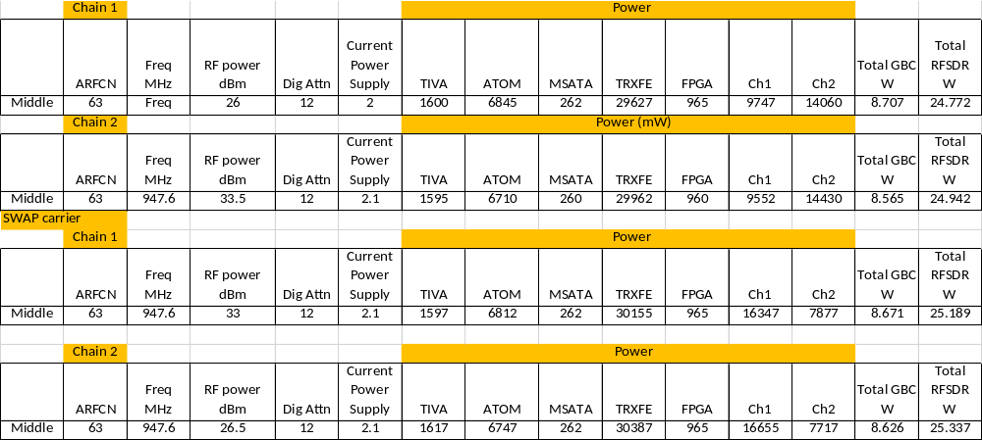
TOTAL POWER CONSUMPTION |  |  |  | RESULT (PASS /FAIL)
GBC  W | RFSDR  W | Total  W | Total Power Margin  (in W) | RESULT (PASS /FAIL)
Spec (10W) | Spec (35W) | Spec (45W)
8.64 | 31.74 | 40.38 | 4.62 | PASS

Note:-

GBC Power (in W) = TIVA + ATOM + MSATA
RFSDR Power (in W) = FPGA + Ch1 + Ch2

Total Power (in W) = GBC Power + RFSDR Power
GSM1800
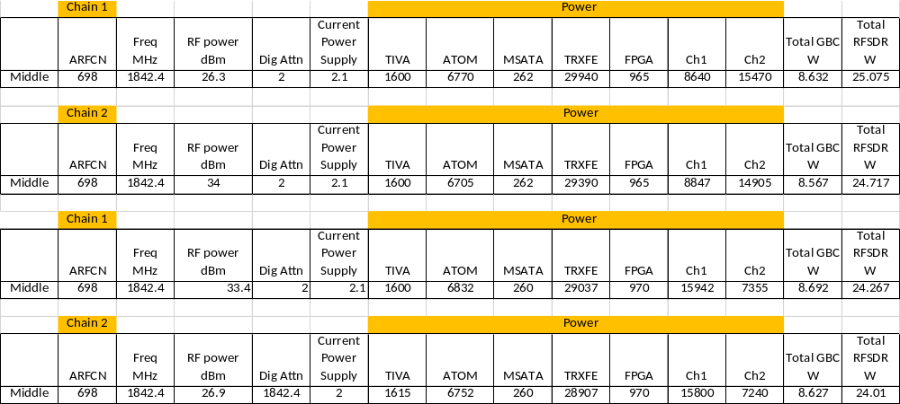

TOTAL POWER CONSUMPTION |  |  |  | RESULT (PASS /FAIL)
GBC  W | RFSDR  W | Total  W | Total Power Margin  (in W) | RESULT (PASS /FAIL)
Spec (10W) | Spec (35W) | Spec (45W)
6.47 | 30.85 | 37.32 | 7.68 | PASS

Note: -

GBC Power (in W) = TIVA + ATOM + MSATA
RFSDR Power (in W) = FPGA + Ch1 + Ch2

Total Power (in W) = GBC Power + RFSDR Power

WITH BATTERY CHARGING
POWER SOURCE – AUX 22VDC
GSM900
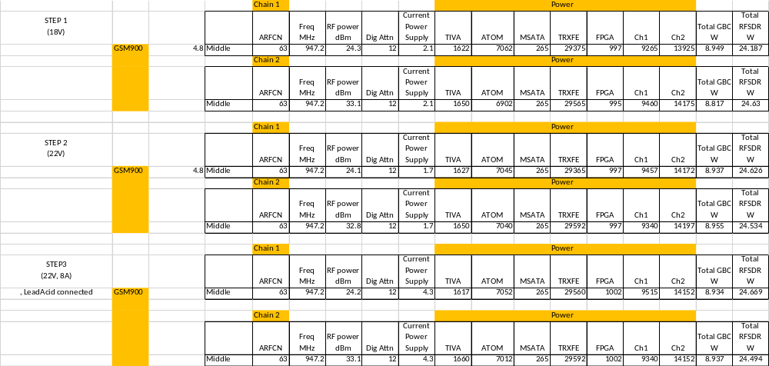
STEP 1 (BASELINE)
TOTAL POWER CONSUMPTION |  |  |  | RESULT  (PASS /FAIL)
GBC  W | RFSDR  W | Total  W | Total Power Margin  (in W) | RESULT  (PASS /FAIL)
Spec (10W) | Spec (35W) | Spec (45W)
8.95 | 24.63 | 33.58 | 11.42 | PASS

Note: -

GBC Power (in W) = TIVA + ATOM + MSATA
RFSDR Power (in W) = FPGA + Ch1 + Ch2

Total Power (in W) = GBC Power + RFSDR Power

STEP 2 (at 22VDC without battery charging)
TOTAL POWER CONSUMPTION |  |  |  | RESULT  (PASS /FAIL)
GBC  W | RFSDR  W | Total  W | Total Power Margin  (in W) | RESULT  (PASS /FAIL)
Spec (10W) | Spec (35W) | Spec (45W)
8.94 | 24.53 | 33.47 | 11.53 | PASS

Note: -

GBC Power (in W) = TIVA + ATOM + MSATA
RFSDR Power (in W) = FPGA + Ch1 + Ch2

Total Power (in W) = GBC Power + RFSDR Power

STEP 3 (at 22VDC with battery charging)
TOTAL POWER CONSUMPTION |  |  |  | Battery Charging | Battery Charge Current  A | RESULT  (PASS /FAIL)
GBC  W | RFSDR  W | Total  W | Total Power Margin  (in W) | Battery Charging | Battery Charge Current  A | RESULT  (PASS /FAIL)
Spec (10W) | Spec (35W) | Spec (45W) |  | Functional | Spec < 10.8A
8.93 | 23.49 | 32.43 | 12.57 | OK | 5.7 | PASS

Note: -

GBC Power (in W) = TIVA + ATOM + MSATA
RFSDR Power (in W) = FPGA + Ch1 + Ch2

Total Power (in W) = GBC Power + RFSDR Power

System Power – Solar power
9.9.1 Test ID
Sys Pwr 1.5
9.9.2 Purpose
The purpose of this test case is to validate system performance when operated with Solar power source.
9.9.3 Test and Measurement Method
Refer to section 5.1.5 of OpenCellular - Connect-1 System Test Specification document
9.9.4 Test Condition
Ambient Temperature: 25˚C
Operating Voltage: Nominal
System/Test Load: Typical
9.9.5 DUT Sample Information
RF-SDR Board Serial Number – WZ1630LIFE2SDR0008
GBC Board Serial Number – WZ1630LIFE2GBC0022

9.9.6 Test Results
WITHOUT BATTERY CHARGING
GSM900
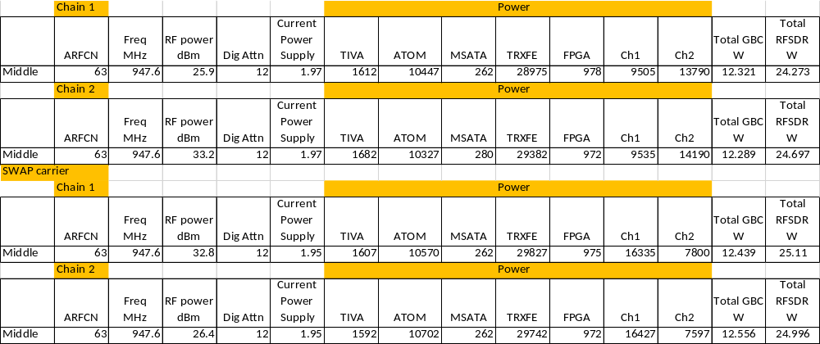

TOTAL POWER CONSUMPTION |  |  |  | RESULT  (PASS /FAIL)
GBC  W | RFSDR  W | Total  W | Total Power Margin  (in W) | RESULT  (PASS /FAIL)
Spec (10W) | Spec (35W) | Spec (45W)
12.40 | 31.50 | 43.90 | 1.1 | PASS
GSM1800

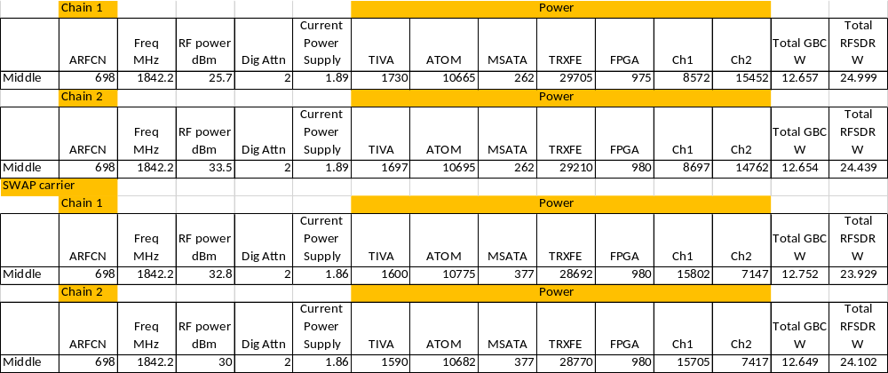

TOTAL POWER CONSUMPTION |  |  |  | RESULT  (PASS /FAIL)
GBC  W | RFSDR  W | Total  W | Total Power Margin  (in W) | RESULT  (PASS /FAIL)
Spec (10W) | Spec (35W) | Spec (45W)
12.68 | 31.54 | 44.22 | 0.78 | PASS
WITH BATTERY CHARGING
NOTE: No RF transmission, with electronic load
STEP 1: No battery connected
 | Value | Parameter | Units | Specification
Solar Source | 21.48 | Voltage on Solar Source Display | V
Solar Source | 2.05 | Current on Solar Source Display | A
Solar Source | 44.034 | Power from Solar Source | W | < 45W
Solar Source | 21.86 | Voltage on GBC Front panel connector | V
Electronic Load | 3.4 | Current on Electronic load | A
Electronic Load | 12 | Voltage on electronic load terminals | V
Electronic Load | 40.8 | Power to Electronic Load | W

STEP 2: External battery connected
 | Value | Parameter | Units | Specification
Solar Source | 20.1 | Voltage on Solar Source Display | V
Solar Source | 5.06 | Current on Solar Source Display | A
Solar Source | 101.706 | Power from Solar Source | W | < 165W
Solar Source | 20.3 | Voltage on GBC Front panel connector | V
Electronic Load | 3.4 | Current on Electronic load | A
Electronic Load | 12 | Voltage on electronic load terminals | V
Electronic Load | 40.8 | Power to Electronic Load | W

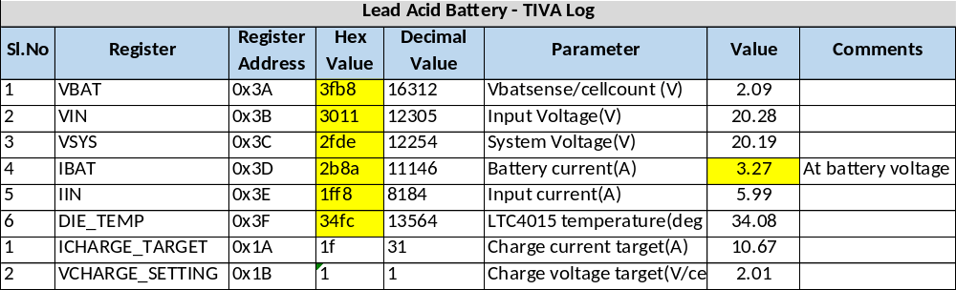
Charge Current | Margin  (in Amp) | RESULT (PASS/FAIL)
Spec (< 10.8A)
6A | 4.8A | PASS

STEP 3: Internal battery connected
 | Value | Parameter | Units | Specification
Solar Source | 21.26 | Voltage on Solar Source Display | V
Solar Source | 2.522 | Current on Solar Source Display | A
Solar Source | 53.61772 | Power from Solar Source | W | < 65.4W
Solar Source | 21.55 | Voltage on GBC Front panel connector | V
Electronic Load | 3.4 | Current on Electronic load | A
Electronic Load | 12 | Voltage on electronic load terminals | V
Electronic Load | 40.8 | Power to Electronic Load | W

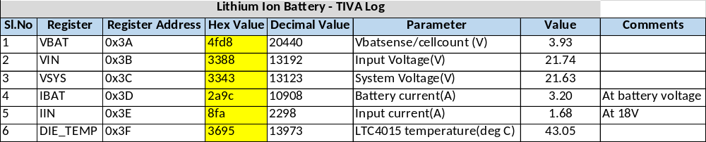
Charge Current | Margin  (in Amp) | RESULT (PASS/FAIL)
Spec (< 1.8A)
1.7A | 0.1 A | PASS

Note:-

GBC Power (in W) = TIVA + ATOM + MSATA
RFSDR Power (in W) = FPGA + Ch1 + Ch2

Total Power (in W) = GBC Power + RFSDR Power

System Power - POE
9.10.1 Test ID
Sys Pwr 1.4
9.10.2 Purpose
The purpose of this test case is to ensure systems functions normally when powered with POE source.
9.10.3 Test and Measurement Method
Refer to section 5.1.4 of OpenCellular - Connect-1 System Test Specification document
9.10.4 Test Condition
Ambient Temperature: 25˚C
Operating Voltage: Nominal
System/Test Load: Typical
9.10.5 DUT Sample Information
RF-SDR Board Serial Number – WZ1630LIFE2SDR0008
GBC Board Serial Number – WZ1630LIFE2GBC0022
9.10.6 Test Results
GSM900
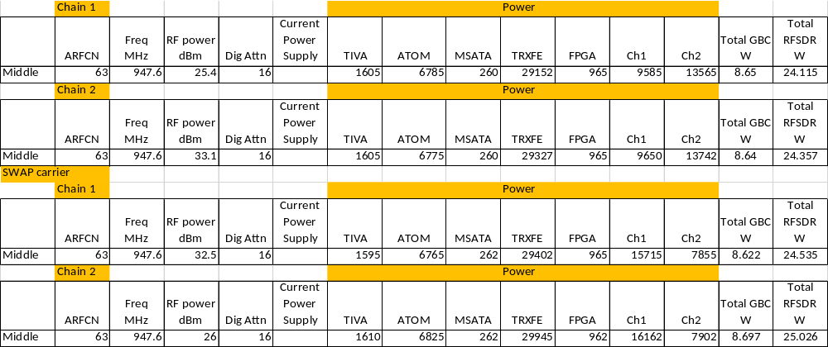

TOTAL POWER CONSUMPTION |  |  |  | RESULT  (PASS /FAIL)
GBC  W | RFSDR  W | Total  W | Total Power Margin  (in W) | RESULT  (PASS /FAIL)
Spec (10W) | Spec (35W) | Spec (45W)
8.65 | 30.42 | 39.07 | 5.93 | PASS

Note:-

GBC Power (in W) = TIVA + ATOM + MSATA
RFSDR Power (in W) = FPGA + Ch1 + Ch2

Total Power (in W) = GBC Power + RFSDR Power

GSM1800
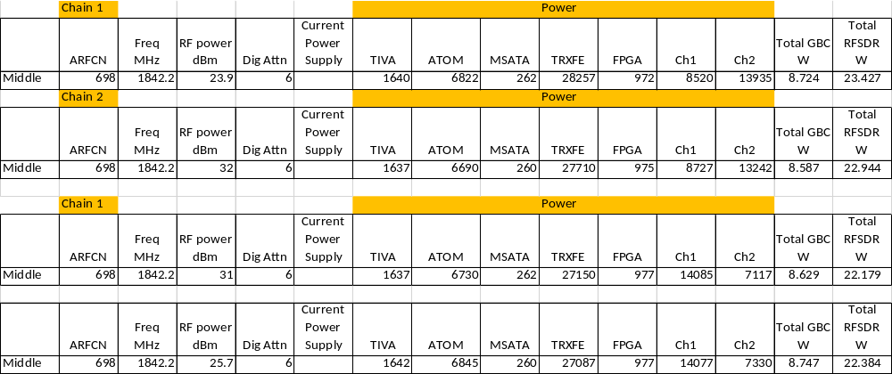

TOTAL POWER CONSUMPTION |  |  |  | RESULT  (PASS /FAIL)
GBC  W | RFSDR  W | Total  W | Total Power Margin  (in W) | RESULT  (PASS /FAIL)
Spec (10W) | Spec (35W) | Spec (45W)
8.67 | 28.30 | 36.97 | 8.03 | PASS
Note: -

GBC Power (in W) = TIVA + ATOM + MSATA
RFSDR Power (in W) = FPGA + Ch1 + Ch2

Total Power (in W) = GBC Power + RFSDR Power

System Power – External Battery
9.11.1 Test ID
Sys Pwr 1.7
9.11.2 Purpose
The purpose of this test case is to ensure systems functions normally when powered with External battery.
9.11.3 Test and Measurement Method
Refer to section 5.1.7 of OpenCellular - Connect-1 System Test Specification document
9.11.4 Test Condition
Ambient Temperature: 25˚C
Operating Voltage: Nominal
System/Test Load: Typical
9.11.5 DUT Sample Information
RF-SDR Board Serial Number – WZ1630LIFE2SDR0008
GBC Board Serial Number – WZ1630LIFE2GBC0022
9.11.6 Test Results
GSM900
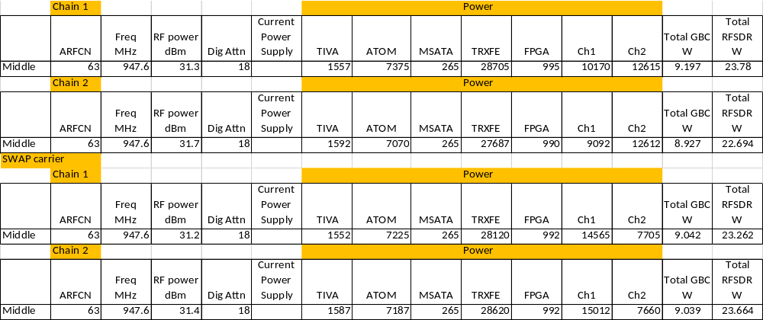

TOTAL POWER CONSUMPTION |  |  |  | RESULT  (PASS /FAIL)
GBC  W | RFSDR  W | Total  W | Total Power Margin  (in W) | RESULT  (PASS /FAIL)
Spec (10W) | Spec (35W) | Spec (45W)
9.05 | 28.17 | 37.22 | 7.78 | PASS
Note:-

GBC Power (in W) = TIVA + ATOM + MSATA
RFSDR Power (in W) = FPGA + Ch1 + Ch2

Total Power (in W) = GBC Power + RFSDR Power

GSM1800
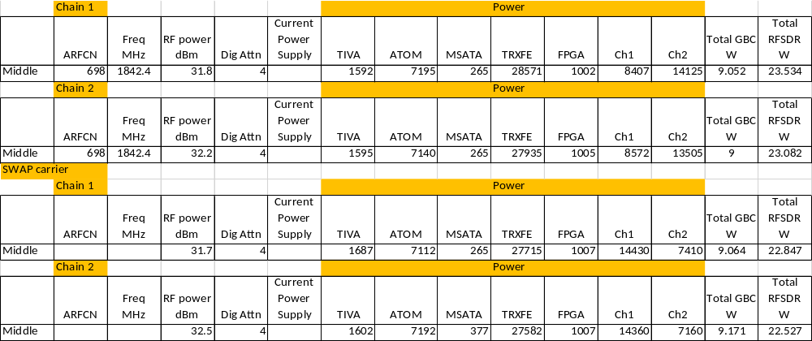

TOTAL POWER CONSUMPTION |  |  |  | RESULT  (PASS /FAIL)
GBC  W | RFSDR  W | Total  W | Total Power Margin  (in W) | RESULT  (PASS /FAIL)
Spec (10W) | Spec (35W) | Spec (45W)
9.07 | 28.94 | 38.01 | 6.99 | PASS
Note:-

GBC Power (in W) = TIVA + ATOM + MSATA
RFSDR Power (in W) = FPGA + Ch1 + Ch2

Total Power (in W) = GBC Power + RFSDR Power

System Power – Internal Battery
9.12.1 Test ID
Sys Pwr 1.6
9.12.2 Purpose
The purpose of this test case is to ensure systems functions normally when powered with Internal battery.
9.12.3 Test and Measurement Method
Refer to section 5.1.6 of OpenCellular - Connect-1 System Test Specification document
9.12.4 Test Condition
Ambient Temperature: 25˚C
Operating Voltage: Nominal
System/Test Load: Typical
9.12.5 DUT Sample Information
RF-SDR Board Serial Number – WZ1630LIFE2SDR0008
GBC Board Serial Number – WZ1630LIFE2GBC0018
9.12.6 Test Results
GSM900
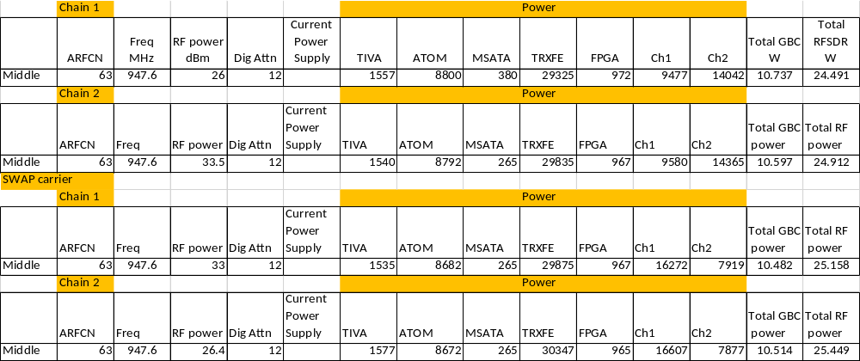

TOTAL POWER CONSUMPTION |  |  |  | RESULT  (PASS /FAIL)
GBC  W | RFSDR  W | Total  W | Total Power Margin  (in W) | RESULT  (PASS /FAIL)
Spec (10W) | Spec (35W) | Spec (45W)
10.58 | 31.61 | 42.19 | 2.79 | PASS

System Power – Cold Start
9.13.1 Test ID
Sys Pwr 1.3
9.13.2 Purpose
The purpose of this test case is to validate the logic for COLD start
9.13.3 Test and Measurement Method
Refer to section 5.1.3 of OpenCellular - Connect-1 System Test Specification document
9.13.4 Test Condition
Ambient Temperature: 25˚C
Operating Voltage: Nominal
System/Test Load: Typical
9.13.5 DUT Sample Information
RF-SDR Board Serial Number – WZ1630LIFE2SDR0008
GBC Board Serial Number – WZ1630LIFE2GBC0022
9.13.6 Test Results

VALIDATION STEP | OBSERVATION | REMARKS
Ambient temperature | 21 degC
Threshold value | 30 degC | for INTEL temperature Sensor
Before temperature threshold
GBC power | OK
RF board power | ON HOLD
PA enables | ON HOLD
FX3 reset (active low) | ON HOLD
After temperature threshold
GBC power | OK
RF board power | OK
PA enables | OK
FX3 reset (active low) | OK
Test result (PASS / FAIL) | PASS | Functional Validation of COLD START LOGIC

System Power – Power (Initialization) Sequence
9.14.1 Test ID
Sys Pwr 1.2
9.14.2 Purpose
The purpose of this test case is to validate the logic for system power up (initialization sequence)
9.14.3 Test and Measurement Method
Refer to section 5.1.2 of OpenCellular - Connect-1 System Test Specification document
9.14.4 Test Condition
Ambient Temperature: 25˚C
Operating Voltage: Nominal
System/Test Load: Typical
9.14.5 DUT Sample Information
RF-SDR Board Serial Number – WZ1630LIFE2SDR0008
GBC Board Serial Number – WZ1630LIFE2GBC0022

9.14.6 Test Results

S.No |  | Initialization Process Step | Device involved | RESULT  OK / NOK | REMARKS
1 | a | Check Power source | POE | OK | POE not connected
1 | b |  | Solar/AUX | OK | Detected AUX power source
1 | c |  | Lithium-ion Battery | OK | Detected Li-ion battery
1 | d |  | Lead Acid Battery | OK | Lead acid not Connected
1 | e |  | PSE | OK | POE not connected, powered by AUX
2 | a | Check - INTEL out of RESET | PSTRST | OK | Checking INTEL out of RESET
2 | b |  | COREPOWER | OK | Checking INTEL power OK
3 | a | Check - MSATA out of RESET |  | OK | Checking MSATA out of RESET
4 | a | Check - RF out of RESET |  | OK | Checking RFSDR out of RESET
5 | a | Checking Device presense | INA226 - GBC (4) | OK | Checks the presence of Current and Voltage monitoring devices on GBC
5 | b |  | INA226 - RF (3) | OK | Checks the presence of Current and Voltage monitoring devices on RFSDR
5 | c |  | Temp Sensor - GBC (6) | OK | Checks the presence of temperature sensors on GBC
5 | d |  | Temp Sensor - RF (2) | OK | Checks the presence of temperature sensors on RFSDR
5 | e |  | Sync module | OK | Checks the presence of Sync Module
5 | f |  | LED module | OK | Checks the presence of LED module
6 | a | Configuration / Initialization of Sensors | INA226 - GBC (4) | OK | Configuring INA226 on GBC
6 | b |  | INA226 -RF (3) | OK | Configuring INA226 on RFSDR
6 | c |  | PSE | OK | no POE connected
6 | d |  | Lead Acid | OK | Configuring charge controller for Lead Acid battery
6 | e |  | Lithium-ion | OK | Configuring charge controller for Li-ion battery
6 | f |  | Temp Sensor - GBC (6) | OK | Configuring temperature sensor limits for GBC
6 | g |  | Temp Sensor - RF (2) | OK | Configuring temperature sensor limits for RFSDR
6 | h |  | Sync module | OK | Configuring I/O expander for SYNC module
6 | i |  | LED module | OK | Configuring I/O expander for LED module
7 | a | Checking device Status | INA226 - GBC (4) | OK | Monitoring bus currents and voltages for GBC
7 | b |  | INA226 - RF (3) | OK | Monitoring bus currents and voltages for GBC
7 | c |  | Temp Sensor - GBC (6) | OK | Monitoring temperature reading on GBC
7 | d |  | Temp Sensor - RF (2) | OK | Monitoring temperature reading on RFSDR
FINAL STATUS |  |  |  | PASS

System RF – GPS lock
9.15.1 Test ID
Sys GPS 1.1
9.15.2 Purpose
The purpose of this test case is to validate GPS receiver performance.
9.15.3 Test and Measurement Method
Refer to section 8.1.1 of OpenCellular - Connect-1 System Test Specification document
9.15.4 Test Condition
Ambient Temperature: 25˚C
Operating Voltage: Nominal
System/Test Load: Typical
9.15.5 DUT Sample Information
RF-SDR Board Serial Number – WZ1630LIFE2SDR0008
GBC Board Serial Number – WZ1630LIFE2GBC0022

9.15.6 Test Results

GPSDO Lock detect | GPSDO lock time  (Spec < 15mts) | Margin  For GPSDO Lock | 40MHz reference output | RESULT  PASS /FAIL
OK | 10 minutes | 5 Minutes | OK | PASS

System RF – GPS-GSM Coexistence
9.16.1 Test ID
Sys GPS 1.2
9.16.2 Purpose
Purpose: To test the coexistence of GPS-GSM in the same BOX. GSM signal transmission should have no impact on GPS signal reception.
9.16.3 Test and Measurement Method
Refer to section 8.1.2 of OpenCellular - Connect-1 System Test Specification document
9.16.4 Test Condition
Ambient Temperature: 25˚C
Operating Voltage: Nominal
System/Test Load: Typical
9.16.5 DUT Sample Information
RF-SDR Board Serial Number –WZ1630LIFE2SDR00 08
GBC Board Serial Number – WZ1630LIFE2GBC0022

9.16.6 Test Results

GPS - Standalone
S.No | GPS Signal Level (dBm) | C/No  (dBm/Hz) | Remarks
1 | -140 | 26 | No GPS Fix
2 | -135 | 31 | GPS fix
3 | -130 | 38 | GPS fix
4 | -125 | 42 | GPS fix
5 | -120 | 45 | GPS fix
6 | -115 | 49 | GPS fix
7 | -110 | 51 | GPS fix
8 | -105 | 51 | GPS fix

GPS-GSM900 Coexistence
GSM Tx Power = 33dBm
GPS Signal Input = -130dBm

Variable Attenuation  (dB) | Total GSM - GPS Isolation (dB) | C/No | Remarks
no GSM transmission |  | 38 | GPS Fix
40 | 50 | 35 | GPS Fix
35 | 45 | 33 | GPS Fix
30 | 40 | 31 | GPS Fix
25 | 35 | 29 | GPS Fix
20 | 30 | 28 | GPS Fix
15 | 25 | 25 | no GPS fix

GPS-GSM1800 Coexistence
GSM Tx Power = 33dBm
GPS Signal Input = -130dBm
Variable Attenuation  (dB) | Total Gsm - GPS Isolation (dB) | C/No  (dBc / Hz) | Remarks
no GSM transmission |  | 35 | GPS Fix
40 | 50 | 34 | GPS Fix
35 | 45 | 33 | GPS Fix
30 | 40 | 31 | GPS Fix
25 | 35 | 31 | GPS Fix
20 | 30 | 30 | GPS Fix
15 | 25 | 29 | no GPS fix

Parameter | Specification | Result | Margin | RESULT  PASS / FAIL
With and input of -130dBm, GPS Fix and PLL Lock to be achieved for up to a minimum of GPS-GSM isolation of | 35 dB | 30dB | 5 dB | PASS
Time for GPSDO lock detect for GPS input of -130dBm and GPS-GSM coupling of 35dB | < 15 minutes | 6 minutes | 9 Minutes | PASS

History

SL.no | Date | Version | Author | Comments
1 | February 9th ,2017 | 1.0 | OpenCellular Team | First Release
2 | February 13th, 2017 | 1.1 | OpenCellular Team | Incorporated comments on 1st and 2nd page of the report

