OpenCellular - Connect1  System Test Specifications | Version 1.0

History.
SL.no | Date | Version | Author | Comments
1 | February 9th, 2017 | 1.0 | OpenCellular Team | First Release

Table of Contents

Table of Contents 3
List of Figures 5
List of Tables 6
1. Purpose and Scope. 8
2. Abbreviation 9
3. System Clock 10
3.1 Test Purpose and Description 10
3.1.1 Test Case: Frequency Error & Lock detect 10
4. System Control 13
4.1 Test Purpose and Description 13
4.1.1 Test Case: LDO enables, Power amplifier enables, regulator enables, RF switch on Tx and Rx paths 14
4.1.2 Test Case: System Controls - Reset 20
4.1.3 Test Case: System alarms 23
4.1.4 Test Case: LED status 26
5. System Power 28
5.1 Test Purpose and Description 29
5.1.1 Test Case: Total power consumption, AUX power source 30
5.1.2 Test Case: Power (Initialization) Sequencing 34
5.1.3 Test Case: Cold start 37
5.1.4 Test Case: Testing with POE++ 39
5.1.5 Test Case: Testing with solar power 42
5.1.6 Test Case: Testing with internal battery 46
5.1.7 Test Case: Testing with external battery 49
6. System RF – Tx 52
6.1 Test Purpose and Description 52
6.1.1 Test Case: Modulation accuracy 53
6.1.2 Test Case: Mean transmitted RF carrier power 57
6.1.3 Test Case: Transmitted RF carrier vs time 60
6.1.4 Test Case: spectrum due to modulation and wideband noise 65
6.1.5 Test Case: Switching transient spectrum 71
6.1.6 Test Case: Spurious emission - Inside the BTS Transmit Band 76
6.1.7 Test Case: Spurious emission - Outside the BTS Transmit Band 79
6.1.8 Test Case: Intermodulation attenuation (GSM900, DCS1800) 88
6.1.9 Test Case: Intra BTS Intermodulation attenuation 91
7. System RF Rx 92
7.1 Test Purpose and Description 92
7.1.1 Test Case: NER static 93
7.1.2 Test Case: NER EQ-50 93
7.1.3 Test Case: High level RACH (NER RACH), static 93
7.1.4 Test Case: Static reference sensitivity level, TCH/FS, 8PSK 93
7.1.5 Test Case: Static sensitivity reference level, all other logical channels 93
7.1.6 Test Case: Multipath sensitivity level ,TCH/FS, 8PSK 93
7.1.7 Test Case: Multipath sensitivity level, all other logical channels 93
7.1.8 Test Case: Reference interference level, TCH/FS, 8PSK 93
7.1.9 Test Case: Reference interference level, all other logical channels 93
7.1.10 Test Case: Blocking and spurious response rejection 93
7.1.11 Test Case: Intermodulation rejection, TCH/FS , 8PSK 93
7.1.12 Test Case: AM suppression, TCH/FS, 8PSK 93
7.1.13 Test Case: Received signal measurement accuracy 93
7.1.14 Test Case: Received signal level & selectivity 93
7.1.15 Test Case: Spurious emissions from the RX antenna connector 93
8. System RF GPS 94
8.1 Test Purpose and Description 94
8.1.1 Test Case: GPS lock 94
8.1.2 Test Case: GPS – GSM coexistence 96
9. System Electrical Compliance 98
9.1 Test Purpose and Description 98
9.1.1 Test Case: Radiated emission 98
9.1.2 Test Case: Conducted emission 98
9.1.3 Test Case: Radiated electromagnet field immunity 98
9.1.4 Test Case: Fast transients immunity 98
9.1.5 Test Case: Ethernet fast transient immunity 98
9.1.6 Test Case: RF common mode immunity 98
9.1.7 Test Case: Ethernet RF common mode immunity 98
9.1.8 Test Case: Safety requirements 98
9.1.9 Test Case: ESD 98
9.1.10 Test Case: DC port lightning surge protection (OVP) 98
9.1.11 Test Case: Antenna port lightning surge 98
9.1.12 Test Case: Ethernet lightning surge 98
10. Test equipment 99
11. Test software licenses 99
12. References 100

List of Figures
Figure 1 System clock Test Setup Block Diagram 11
Figure 2 System control - LDO enables, Power amplifier enables, regulator enables, RF switch on Tx and Rx paths test setup 15
Figure 3 System control - RESET test setup 20
Figure 4 LED module test setup 23
Figure 5 LED module test setup 26
Figure 6 System power – AUX DC source and Total power consumption test setup 30
Figure 7 System power – Power (Initialization) sequence test setup 34
Figure 8 System power – Cold start logic test setup 37
Figure 9 System power – PoE source and Total power consumption test setup 39
Figure 10 System power – Solar source and Total power consumption test setup 43
Figure 11 System power – Li-Ion DC source and Total power consumption test setup 46
Figure 12 System power – Lead Acid battery source and Total power consumption test setup 49
Figure 13 System Modulation accuracy test setup block diagram 54
Figure 14 System Mean transmitted RF carrier power test setup block diagram 58
Figure 15 System Power vs Time test setup block diagram 61
Figure 16 Power vs Time mask for GSM800, GSM900, DCS1800 62
Figure 17 Power vs Time mask for PCS 1900 GMSK modulation 63
Figure 18 Power vs Time mask for PCS 1900 8-PSK modulation 64
Figure 19 Test Set-up for Spectrum due to Modulation for offsets up to 1800kHz 65
Figure 20 Test Set-up for Spectrum due to Modulation for offsets 1800kHz from the carrier up to 6MHz outside the BTS transmit band 66
Figure 21 Test Set-up for Spectrum due to switching transients for offsets up to 1800kHz 71
Figure 22 Power/Timeslot configuration for Switching Transients Spectrum (RF Static Power Control) 73
Figure 23 Power / timeslot configuration for Switching Transients Spectrum (RF Power Control) 73
Figure 13 Example of a time waveform due to a burst as seen in a 30 kHz filter offset from the carrier 73
Figure 25 Manual Test Set-up for Transmitter Conducted Spurious Emissions from the Antenna Connector: Inside the BTS Transmit Band 76
Figure 26 Manual Test Set-up for Transmitter Conducted Spurious Emissions from the Antenna Connector: Outside the BTS Transmit Band 79
Figure 27 Manual Test Set-up for Transmitter Intermodulation attenuation 88
Figure 28 GPS lock test setup block diagram 94
Figure 29 GPS-GSM coexistence test setup block diagram 97

List of Tables

Table 1. GSM/EDGE channel definitions 8
Table 2. Acronyms Used in this Document 9
Table 3. Signal Generator Settings 11
Table 4. Spectrum Analyser Settings 11
Table 5. Frequency error Test Specification 12
Table 6. Test Condition 12
Table 7. LDO enables, Power amplifier enables, regulator enables, RF switch on Tx and Rx paths test Specification 17
Table 8. Test Condition 17
Table 9. System control - RESET test Specification 21
Table 10. Test Condition 21
Table 11. System alarms test Specification 24
Table 12. Test Condition 25
Table 13. LED module Test Specification 27
Table 14. Test Condition 28
Table 15. System power: Aux supply and Total power consumption test specification 32
Table 16. Test Condition 32
Table 17. System power: cold start test specification 36
Table 18. Test Condition 36
Table 19. System power: cold start test specification 38
Table 20. Test Condition 38
Table 21. System power: PoE supply test specification 40
Table 22. Test Condition 40
Table 23. System power: Solar source test specification 43
Table 24. Test Condition 44
Table 25. Solar simulator configuration 44
Table 26. System power: Li-Ion Battery source test specification 47
Table 27. Test Condition 47
Table 28. System power: Lead Acid battery source test specification 50
Table 29. Test Condition 50
Table 30. Modulation accuracy Test Specification 56
Table 31. Test Condition 56
Table 32. Mean transmitted RF carrier power – maximum static power level specification 59
Table 33. Test Condition 59
Table 34. Test Condition 64
Table 35. Offsets measured for Adjacent Channel Power – Spectrum due to modulation and wideband noise < +/-1800 KHz. 67
Table 36. Modulation Spectrum and Wideband Noise Spectrum Analyzer Settings 68
Table 37. Continuous modulation spectrum - maximum limits for BTS 68
Table 38. Test Condition 69
Table 39. Switching Transients Spectrum - Maximum Limits 74
Table 40. Test Condition 74
Table 41. In-band Spurious Emission Spectrum Analyzer Settings 77
Table 42. Test Condition 78
Table 43. Limits for Spurious Emissions from the Transmitter Antenna Connector (900) 81
Table 44. Limits for Spurious Emissions from the Transmitter Antenna Connector (1800) 82
Table 45. Limits for Spurious Emissions from the Transmitter Antenna Connector (900 Type Approval with Alternating Timeslots) 84
Table 46. Limits for Spurious Emissions from the Transmitter Antenna Connector (1800 Type Approval with Alternating Timeslots) 85
Table 47. Test Condition 86
Table 48. 3GPP TS 51.021 Resolution Bandwidths used in Transmitter Conducted Spurious Emissions from the Antenna Connector - Outside the BTS Transmit Band. 87
Table 49. Intermodulation attenuation specification 89
Table 50. Test Condition 90
Table 51. GPS lock requirement specification 95
Table 52. Test Condition 95
Table 53. GPS-GSM isolation requirement specification 97
Table 54. Test Condition 97

Purpose and Scope.

The purpose of this document is to detail the design validation and verification requirements of CONNECT 1 GSM BTS system. The document is intended to provide fundamental set of test specifications required to ensure consistent and reliable operation of BTS under all supported operating and environmental conditions.
These test specification covers following components of BTS system:
- Clock
- System Controls
- System Power
- System TX
- System RX
- System GPS
- System Electrical Compliance
The testing shall be performed on the following bands: GSM850, GSM900, GSM1800, GSM1900
Channel configurations shall be as indicated in Table 1.
GSM900
CHANNEL | ARFCN | TX FREQ | RX FREQ
B | 975 | 925.2 | 880.2
M | 38 | 942.6 | 897.6
T | 124 | 959.8 | 914.8

DCS1800
CHANNEL | ARFCN | TX FREQ | RX FREQ
B | 512 | 1805.2 | 1710.2
M | 699 | 1842.6 | 1747.6
T | 885 | 1879.8 | 1784.8
Table 1. GSM/EDGE channel definitions

Abbreviation

Acronym | Explanation
3GPP | 3rd Generation Partnership Project
8-PSK | 8 Level Phase Shift Keying
ADC | Analog to Digital Converter
ANT | Antenna
BOM | Bill of Material
BTS | Base Transceiver Station
BSSTE | Base Station System Test Equipment
DAC | Digital t Analog converter
ETSI | European Telecommunications Standards Institute
EVM | Error vector magnitude
FCC | Federal Communications Communication
FS | Full Rate
GBC | General Purpose Baseband and Computing
GPRS | General Packet Radio Service
GSM | Global System for Mobile
GSMK | Gaussian Minimum Shift Keying
HW | Hardware
LED | Light Emitting Diode
LNA | Low Noise Amplifier
NF | Noise Figure
PA | Power Amplifier
PCB | Printed Circuit Board
RF | Radio Frequency
RFSDR | Radio Frequency Software Defined Radio
Rx | Receiver
TCH | Traffic Channel
TI | Texas Instruments
Tx | Transmitter
UART | Universal Asynchronous Receiver Transmitter
VGA | Variable Gain Attenuator

Table 2. Acronyms Used in this Document

System Clock

The function of system clock is to synchronise BTS transmission across other network elements and also to synchronize digital signals across different sections of the system. CONNECT-1 BTS has interface for GPS device for synchronization purposes; 1PPS and GPS time stamp and control interfaces.
GBC module provides the 40MHz reference, which is locked to GPS, to the clock module on RFSDR. Clock distribution part generates the needed reference signals for synthesizers, ADCs, DACs and digital ICs.

Test Purpose and Description
The purpose of this test is to verify and validate that clock generation and distribution. Verification and validation of the system clock covers following functions and features:
- Frequency accuracy
- Lock detect

Test Case: Frequency Error & Lock detect

Description
- Purpose
The purpose of this test case is to verify and validate frequency accuracy of Tx signal. Also to verify and ensure lock detect of system clock module.
- Impact of failure
Failure to conform to frequency accuracy or lock detect will degrade BTS system performance, or even result in non-compliance. The failure indicates issue with system clock.

Test Equipment List
- Power supply (E3634A or Equivalent)
- Signal Analyzer (N9010A or Equivalent)

Test Setup
- Setup Block diagram

Spectrum
Analyzer
CONNECT 1
Power Supply
ANT1 / ANT2
Attenuator
10MHz, External reference

Figure 1 System clock Test Setup Block Diagram

- Measurement Locations
- Antenna connectors
- Equipment Settings
- Keysight N9010A vector signal analyzer
Band | Bottom(MHz) | Middle(MHz) | Top(MHz)
GSM900 | 925 | 942 | 960
GSM850 | 870 | 881 | 892
GSM1800 | 1806 | 1842 | 1879
GSM1900 | 1931 | 1959 | 1989
Table 3. Signal Generator Settings
Centre Frequency | Same as Signal Generator input frequency
Span | 10MHz
RBW | 3KHz
Table 4. Spectrum Analyser Settings
- Test Software settings
- TIVA build with Clock PLL lock detect logging enabled

Requirements
Band | Frequency error margin | Frequency accuracy | Lock detect status
GSM900 | <50Hz | 0.05 ppm | Positive Lock detect
GSM850 |  | 0.05 ppm | Positive Lock detect
GSM1800 | <90Hz | 0.05 ppm | Positive Lock detect
GSM1900 |  | 0.05 ppm | Positive Lock detect
Table 5. Frequency error Test Specification

Test Condition
Test condition | Value | Remarks
Frequency | B, M, T | For each band test at Bottom, Middle and top frequencies.
Voltage |  | Nominal voltage
Temperature | +25 C | Normal Room temperature
Table 6. Test Condition

Test Procedure
- Connect test setup according to figure 1 with signal analyser to ANT1
- Set the test conditions according to table 6
- Configure BTS to transmit GSM signal in desired BAND, ARFCN.
- Configure BTS for GSM900, Middle channel, power 10dB below max Tx level (23dBm)
- Set Signal analyser according to Table 6 and channel to GSM900, Middle channel.
- Measure frequency error
- Read lock detect status, using TIVA logs.
- Repeat the measurement for test conditions according to test plan,

Reference
3GPP TS 51 021 section 6.2
Test case reference: Sys Clock 1.1 and Sys Clock 1.2

System Control

System controls cover multiple aspects of system functions like configuring the system according to desired operation (operating band, ARFCN, power level), configuring power supply section, power supply sequencing, handling system alert, LED response to system state, etc.

Test Purpose and Description
The purpose of this test is to verify and validate Base Station transmitter functionality and performance for system control aspects. Verification and validation of the BTS transmitter control aspects covers following functions and features
- Test Case: LDO enables
- Test Case: Power amplifier enables
- Test Case: Regulator enables
- Test Case: Switch controls and enabling 4 bands and 2 chains both on TX and RX side
- Test Case: Reset sequencing
- Test Case: System alarms
- Test Case: LED status

Test Case: LDO enables, Power amplifier enables, regulator enables, RF switch on Tx and Rx paths
Connect 1 system supports GSM bands GSM850, GSM900, GSM1800 and GSM1900. There is also a bypass mode that results in bypassing entire RF front end. At any time one of the bands will be supported. The supported band can be configured using the RF switches in RF front end sections. RF front end also has RF gain control through digital attenuator. There is separate PA enable function to disable the PA that is not in active signal path, this helps same power consumption. When transmission/reception for a particular GSM band is enabled, the associated LDOs are also enabled simultaneously. The control of all these happen through TIVA.

Description
- Purpose
- To verify the implementation of the system controls – LDO enables, Power amplifier enables, regulator enables, RF switch on Tx and Rx paths.
- All measurements are relative measurements to verify functional aspects. Absolute signal level is for reference purpose only
- Impact of failure
A failure of these test cases can imply any of the following
- Improper routing of RF signal, thereby hampering Tx / Rx performance
- Improper RF signal attenuation / gain control

Test Equipment List
- Power supply (E3634A or Equivalent)
- Signal Analyzer (N9010A or Equivalent)
- Signal Generator (N5182B or equivalent)

Test Setup
- Setup Block diagram
Signal
Analyzer (Tx)
Power Supply
Attenuator
CONNECT 1
ANT1 / ANT2
ANT1 / ANT2
High power termination
Debug Board
ETH
Signal
Generator (Rx)
USB
Rx
Rx
Tx

Figure 2 System control - LDO enables, Power amplifier enables, regulator enables, RF switch on Tx and Rx paths test setup

- Measurement Locations
- For Tx: Antenna connector
- For Rx: Test connectors U7116 and U7117

- Test Software settings
- Use TIVA code to configure RF front end paths, Tx / Rx attenuations

- Configuration
- Use TIVA code to configure RF front end paths, Tx / Rx attenuations
.

Requirements

Tx - GSM band configuration, Attenuation control
Tx Chain | Band | AD9361 att = -20
Tx Chain | Band | Tx Att = 0 | Tx Att = 1 | Tx Att = 5 | Tx Att = 10 | Tx Att = 15
 |  | dBm | dB | dB | dB | dB
Ch1 / Ch2 | GSM850 | 28 ± 2dB | 1 ±  0.5dB | 5 ±1dB | 10 ±1dB | 15 ±1.5dB
Ch1 / Ch2 | GSM900 | 28 ± 2dB | 1 ±  0.5dB | 5 ±1dB | 10 ±1dB | 15 ±1.5dB
Ch1 / Ch2 | GSM1800 | 21 ± 2dB | 1 ±  0.5dB | 5 ±1dB | 10 ±1dB | 15 ±1.5dB
Ch1 / Ch2 | GSM1900 | 21 ± 2dB | 1 ±  0.5dB | 5 ±1dB | 10 ±1dB | 15 ±1.5dB

Rx - GSM band configuration, Attenuation control
Rx Chain | Band | Rx Att = 0 | Rx Att = 5 | Rx Att = 10 | Rx Att = 15
Rx Chain | Band | dBm | dB | dB | dB
Ch1 / Ch2 | GSM850 | -22± 2dB | 5 ±1dB | 10 ±1dB | 15 ±1.5dB
Ch1 / Ch2 | GSM900 | -22± 2dB | 5 ±1dB | 10 ±1dB | 15 ±1.5dB
Ch1 / Ch2 | GSM1800 | -40± 2dB | 5 ±1dB | 10 ±1dB | 15 ±1.5dB
Ch1 / Ch2 | GSM1900 | -28± 2dB | 5 ±1dB | 10 ±1dB | 15 ±1.5dB

BTS / Test setup configurations for Tx / Rx
Tx Attn Settings | AD9361 | 20 dB
Rx Attn Settings | ANT input | -30 dBm

Bypass configuration
 |  | Chain 1 | Chain 2
Bypass A | Config | Bypass 1 | Bypass 2
Bypass A | RF path | Tx | Rx
Bypass B | Config | Bypass 2 | Bypass 1
Bypass B | RF path | Rx | Tx

 |  |  | Power (dBm)
 |  |  | GSM850 | GSM900 | GSM1800 | GSM1900
Bypass A / B | Tx | Ch1 | 3 ± 2 dB | 3 ± 2 dB | 0 ± 2 dB | 0 ± 2 dB
Bypass A / B | Rx | Ch2 | -38 ± 2dB | -38 ± 2dB | -40 ± 2dB | -42 ± 2dB

BTS / Test setup configurations for Bypass
Tx Attn Settings | AD9361 | 10dB
Tx Attn Settings | Digital Att | 10dB
Rx Attn Settings | ANT input | -30 dBm

Table 7. LDO enables, Power amplifier enables, regulator enables, RF switch on Tx and Rx paths test Specification

Test Condition
Test condition | Value | Remarks
Frequency | Middle
Voltage |  | Nominal voltage
Temperature | +25 C | Normal Room temperature
Table 8. Test Condition

Test Procedure

- Refer to test setup in figure 2
- Calibrate the test setup
- Tx - GSM band configuration, Attenuation control
  - Connect Signal analyzer to ANT Port 1 (RF Chain 1)
  - Power on the system
  - GSM850-Chain1
    - Configure OSMO cfg files to transmit GSM850, middle channel, AD9361 attenuation of 20dB
    - Initiate transmission.
    - Update TIVA code for GSM850,
    - Update TIVA code for Tx digital attenuation 0dB, Flash TIVA code using CCS
    - Measure GSM signal power at RF chain 1 antenna port.
    - Repeat steps iii to v by updating TIVA code for digital attenuation of 5dB, 10dB and 15dB
  - GSM900 – Repeat step c for GSM900
  - GSM1800 – Repeat step c for GSM1800
  - GSM1900 - Repeat step c for GSM1900
  - Repeat Steps a to f for RF chain 2.
- Rx - GSM band configuration, Attenuation control
  - Connect Signal generator to ANT Port 1 (RF Chain 1)
  - Do the rework for Rx port
    - No Mount: C4409, C4410
    - Mount: C4389, C4390
  - Connect signal analyzer to test connector U7116 for RF chain 1 (U7117 for RF chain- 2)
  - Power on the system
  - GSM850-Chain1
    - Update TIVA code for GSM850,
    - Update TIVA code for Rx digital attenuation 0dB, Flash TIVA code using CCS
    - Measure GSM signal power at RF chain 1 test connector.
    - Repeat steps ii to iii by updating TIVA code for digital attenuation of 5dB, 10dB and 15dB
  - GSM900 – Repeat step e for GSM900
  - GSM1800 – Repeat step e for GSM1800
  - GSM1900 - Repeat step e for GSM1900
  - Repeat steps a to h for RF chain 2
- Bypass configuration
  - Bypass configuration A
    - For Tx Connect Signal analyser to ANT 1 (chain 1)
    - For Rx Connect Signal generator to ANT 2 (chain 2) and Analyzer for Receiver at connector U7117
    - Initiate transmission for GSM850
    - Modify TIVA code for Bypass configuration A and flash
    - Measure signal power levels for Tx and Rx signals
  - Repeat step A for Bypass configuration B

Reference
Test case reference: Sys Ctrl 1.1, Sys Ctrl 1.2, Sys Ctrl 1.3 and Sys Ctrl 1.14

Test Case: System Controls - Reset
Connect 1 system has various RESET controls at module and system levels. The RESET form part of system control. RESET control take part in multiple functions – initialization sequence, response to alerts, reset when an interface/device is non responsive, etc.

Description
- Purpose
- To verify the implementation of the system controls - RESETs.
- Impact of failure
- An incorrect implementation of RESET might cause failure of initialization sequence and also limit the system response to alerts.

Test Equipment List
- Power supply (E3634A or Equivalent)
- Signal Analyzer (N9010A or Equivalent)

Test Setup
- Setup Block diagram
Signal
Analyzer (GSM)
Power Supply
CONNECT 1
Attenuator
ANT1 / ANT2
ANT1 / ANT2
High power termination
Debug Board
ETH
USB

Figure 3 System control - RESET test setup

- Measurement Locations
- Debug connector

- Test Software settings
- Use TIVA code to trigger RESET along with logging enabled for monitoring RESET status

- Configuration
- Use modified TIVA code to trigger RESET along with logging enabled for monitoring RESET status.

Requirements
S.No. | Device | RESET through | Status monitor for out of RESET
1 | TIVA | Switch S1 | TIVA code flash using CCS is success  (If bus voltage is less than 2.9V than TIVA stays in RESET)
2 | INTEL | through TIVA, TIVA_RESET_TO_PROC | Monitor “SOC_PLTRST_N”, logic level HIGH indicates INTEL out of RESET
3 | ETHERNET switch | through TIVA, TIVA_ETHSW_RESET | PING to BTS using Ethernet port (RJ45)
4 | RFSDR RESET | through TIVA, TIVA_TRXFE_RESET | Monitor “TRXFE_RESET_OUT” logic level HIGH indicates RFSDR out of RESET
5 | FX3 | through TIVA, IOE_FX3_RESE (IO expander, address 0x1B) | Run UHD_FIND_DEVICES using INTEL console  (when FX3 is out of RESET we get a response)
6 | RFSDR I/O expander | through TIVA, TIVA_TRXFECONN_GPIO1 | Access RFSDR module IO expander register through I2C, a success indicates device out of RESET
7 | SYNC | Through TIVA, - TIVA_SYNC_RESET | Access Sync module IO expander register through I2C, a success indicates device out of RESET

Table 9. System control - RESET test Specification

Test Condition
Test condition | Value | Remarks
Voltage |  | Nominal voltage
Temperature | +25 C | Normal Room temperature
Table 10. Test Condition

Test Procedure

- Connect test setup according to figure 3
- TIVA RESET
  - Power on the system
  - Flash TIVA code using CCS, a success indicates that TIVA is out of RESET
  - Use switch S1 to RESET TIVA
  - Flash TIVA code using CCS, an error message indicates that TIVA is in RESET
- INTEL RESET
  - Power on the system and let INTEL BOOT normally
  - Flash TIVA code with INTEL RESET using CCS (TIVA_RESET_TO_PROC)
  - Log “SOC_PLTRST_N”, a logic level HIGH indicates that INTEL is out of RESET
- ETHERNET switch RESET
  - Power on the system
  - Connect test PC to BTS using ETHERNET port, initiate continuous PING to BTS (192.168.1.xx) and wait till the PING is successful.
  - Flash TIVA code with ETHERNET switch RESET using CCS (TIVA_ETHSW_RESET).
  - A failure of PING to BTS indicates Ethernet switch is in RESET
- RFSDR RESET
- FX3 RESET
  - Power on the system and let it BOOT normally
  - Run UHD_FIND_DEVICES using INTEL console, a success indicates FX3 is out of RESET
  - Flash TIVA code with FX3 RESET using CCS (IOE_FX3_RESE)
  - Run UHD_FIND_DEVICES using INTEL console, a failure indicates FX3 is in RESET
- RFSDR I/O expander RESET
  - Power on the system and let it BOOT normally
  - Access the I/O expander address, a success indicates I/O expander is out of RESET.
  - Flash TIVA code with I/O expander RESET using CCS (TIVA_TRXFECONN_GPIO1)
  - Access the I/O expander address, a failure indicates I/O expander is in RESET
- SYNC module I/O expander RESET
  - Power on the system and let it BOOT normally
  - Access the I/O expander address, a success indicates I/O expander is out of RESET.
  - Flash TIVA code with I/O expander RESET using CCS (TIVA_SYNC_RESET)
  - Access the I/O expander address, a failure indicates I/O expander is in RESET

Reference
Test case reference: Sys Ctrl 1.5

Test Case: System alarms

Description
Connect 1 system has various sensors to monitor the health of the system. These sensors are in the form of current sensing, temperature sensing, RF circuit block monitoring. The sensors trigger alert based on the threshold limit violation. Threshold limits are set according to the design inputs.
- Purpose
- To verify the implementation of the system alarms.
- Impact of failure
- An incorrect implementation of system alarms might result in BTS getting exposed to extreme stress that might impact BTS performance and may also result in catastrophic failure.

Test Equipment List
- Power supply (E3634A or Equivalent)
- Signal Analyzer (N9010A or Equivalent)

Test Setup
- Setup Block diagram
Signal
Analyzer (GSM)
Power Supply
CONNECT 1
Attenuator
ANT1 / ANT2
ANT1 / ANT2
High power termination
Debug Board

Figure 4 LED module test setup

- Measurement Locations
- DEBUG connector

- Test Software settings
- Use TIVA code with logging enabled for – temperature sensor, current sensors, lock detect.

- Configuration
- Modified TIVA code to simulate alarm conditions

Requirements

S.No. | Module | Reference  Designator | Device | I2C  address | Alert  condition  (logic level LOW) | Threshold for simulating ALARM condition
1 | GBC | U239 | INA226 | 45 | MSATA current sensing | Current, 15mA
2 | GBC | U183 | INA226 | 41 | PWR_12V_ALRT, RFSDR | Current, 500mA
3 | GBC | U185 | INA226 | 44 | PWR_12V_ALRT,  ATOM | Current, 300mA
4 | GBC | U182 | INA226 | 40 | PWR_12V_ALRT,  TIVA | Current, 60mA
5 | GBC | U210 | SE98ATP,547 | 18 | TEMPSEN_TIVA_EVNT1 | Temperature,  LOW:40degC ; HIGH: 30degC
6 | GBC | U211 | SE98ATP,547 | 19 | TEMPSEN_TIVA_EVNT1 | Temperature,  LOW:40degC ; HIGH: 30degC
7 | GBC | U212 | SE98ATP,547 | 1A | TEMPSEN_TIVA_EVNT1 | Temperature,  LOW:40degC ; HIGH: 30degC
8 | GBC | U213 | SE98ATP,547 | 1C | TEMPSEN_TIVA_EVNT2 | Temperature,  LOW:40degC ; HIGH: 30degC
9 | GBC | U214 | SE98ATP,547 | 1D | TEMPSEN_TIVA_EVNT2 | Temperature,  LOW:40degC ; HIGH: 30degC
10 | GBC | U215 | SE98ATP,547 | 1F | TEMPSEN_TIVA_EVNT2 | Temperature,  LOW:40degC ; HIGH: 30degC
11 | RFSDR | U2104 | INA226 | 40 | SYS_ALERT | Current, 500mA
12 | RFSDR | U2105 | INA226 | 41 | SYS_ALERT | Current, 500mA
13 | RFSDR | U32 | INA226 | 44 | 12V_ALRT | Current, 500mA
14 | RFSDR | U1803 | SE98ATP,547 | 18 | CH1_TEMP_SEN_ALERT_CPU | Temperature,  LOW:40degC ; HIGH: 30degC
15 | RFSDR | U2003 | SE98ATP,547 | 1F | CH2_TEMP_SEN_ALERT_CPU | Temperature,  LOW:40degC ; HIGH: 30degC

Table 11. System alarms test Specification

Test Condition
Test condition | Value | Remarks
Voltage |  | Nominal voltage
Temperature | +25 C | Normal Room temperature
Table 12. Test Condition

Test Procedure

- Connect test setup according to figure 4
- Refer to table 11, sr., no. 1, and set threshold for MSATA_current_sensing to simulate ALARM condition.
- Monitor TIVA log for status of signal under “ALERT condition“in table 11
- Repeat steps 2 and 3 for Sr.No. 2, 3, 4, 11, 12 and 13.
- Refer to table 11, sr. no. 5, and set threshold for LOWER temperature limit to simulate ALARM condition.
- Monitor TIVA log for status of signal under “ALERT condition“in table 11
- Set threshold for LOWER temperature limit to simulate ALARM condition.
- Monitor TIVA log for status of signal under “ALERT condition“in table 11
- Repeat steps 5 to 8 for Sr.No. 5, 6, 7, 8, 9, 10, 14 and 15

Reference
Test case reference: Sys Ctrl 1.6

Test Case: LED status

Description
- Purpose
- To verify the correct implementation of the LED module response to system status. LED module is configured and controlled through TIVA
- Impact of failure
- A failure of LED module will result in BTS operator wrongly depicting system state through LED display.

Test Equipment List
- Power supply (E3634A or Equivalent)
- Signal Analyzer (N9010A or Equivalent)

Test Setup
- Setup Block diagram

Signal
Analyzer (GSM)
Power Supply
CONNECT 1
Attenuator
ANT1 / ANT2
ANT1 / ANT2
High power termination
Debug Board

Figure 5 LED module test setup

- Measurement Locations
- LED module

- Test Software settings
- Use TIVA code with logging enabled for – temperature sensor, current sensors, lock detect.
- Modified alert thresholds to simulate alarm conditions.

- Configuration
- Configure TIVA code for generation of LED sequences as per the table 13.

Requirements
# | SYSTEM  STATUS | LED  STATUS | LED COLOR | SYSTEM TEST CONDITION | Remarks
1 | System Boot | Circulating | GREEN | System BOOT
2 | System Running | Pulsing | GREEN | System BOOT completes
3 | System Failure | Pulsing | RED | Associate this to any alarm on GBC. | Temperature: Set the threshold for INTEL temperature sensor to simulate alert (INTEL three temperature limits, LOW, HIGH, CRITICAL: HIGH limit set to 34degC)  Current: Set the INA226 for TIVA current monitoring to simulate alert (TIVA default current ~152 mA, set limit to 100mA to simulate alarm
4 | Radio Failure | Flash – Left | RED | Associate this to Radio alarms | Configure GPS PLL lock detector timeout to simulate radio alert.  (GPS lock alarm timeout set to 2minutes)
5 | Backhaul Failure | Flash - Right | RED | N/A | Test can be performed when BACKHAUL feature is up

Table 13. LED module Test Specification

Test Condition
Test condition | Value | Remarks
Voltage |  | Nominal voltage
Temperature | +25 C | Normal Room temperature
Table 14. Test Condition

Test Procedure

- Connect test setup according to figure 5
- System BOOT: Power up the system
  - Monitor TIVA log for system power sequence
  - Monitor LED display – During BOOT
  - Monitor LED display – when BOOT completes (when system initialization sequence completes)
- System failure
  - Temperature
    - Configure alert threshold for temperature sensor for INTEL to 34degC
    - Monitor TIVA log for INTEL temperature sensor.
    - Monitor LED display to indicate system failure (for INTEL temperature crossing threshold limit)
  - Current
    - Configure alert threshold for INA226 current sense for TIVA to 100mA
    - Monitor TIVA log for INA226 current monitor.
    - Monitor LED display to indicate system failure (for TIVA current crossing threshold limit)
- Radio failure
  - Configure GPS PLL lock detector timeout limit to 2minutes
  - Monitor TIVA log for GPS lock detect
  - Monitor LED display to indicate radio failure (as GPS PLL lock detector threshold limit is crossed)

Reference
Test case reference: Sys Ctrl 1.7

System Power

System power section is responsible of deriving power for the system. It supports multiple power inputs – Solar/AUX DC, PoE, Lead Acid Battery, Li-Ion battery. The power module is designed to support Lead acid and Li-Ion battery charging.

Test Purpose and Description
The purpose of this test is to validate the system power supply section functionality and performance. The following test cases are covered in this section
- Total power consumption
- Power Sequencing
- Cold start with POE++, AUX DC, battery (external/internal)
- Testing with POE++
- Testing with solar power
- Testing with internal battery
- Testing with external battery
- Testing with AUX DC

Test Case: Total power consumption, AUX power source

Description
- Purpose
- To verify that the total power consumption of the BTS is within the specified limits.
- For total power consumption BTS is operated at Maximum Tx output power
- This test is performed with AUX DC power source to verify the system functionality and performance when operated with AUX DC source.
- To verify AUX DC source supporting Transmission at maximum power and simultaneously charging Lead Acid Battery
- Impact of failure
A failure of these test cases will indicate that the System power supply section is stressed electrically and thermally and thereby impacting system reliability.

Test Equipment List
- Power supply (E3634A or Equivalent)
- Signal Analyzer (N9010A or Equivalent)

Test Setup
- Setup Block diagram
Signal
Analyzer (Tx)
Power Supply-AUX
Attenuator
CONNECT 1
ANT1 / ANT2
ANT1 / ANT2
High power termination
Debug Board
Tx
ETH
USB
Lead acid battery

Figure 6 System power – AUX DC source and Total power consumption test setup

- Measurement Locations
- Antenna connector
- Power supply reading
- Debug connector for configuring and monitoring TIVA for logging power consumption using INA226

- Test Software settings
- Use TIVA code to monitor power consumption and charge control IC logs
- Configure BTS Tx path gain for 33dBm RF power at one of the antenna ports.

- Configuration
- Configure BTS to transmit Max Tx power

Requirements
Without battery charging
Module | Power Consumption
GBC | 10W
RFSDR | 35W ¹
Total Power consumption | 45W
RF power transmission | 33dBm ±2dB
AUX output voltage | 16VDC to 24VDC

Note 1: RFSDR power consumption is measured corresponding to 33dBm Tx power at antenna port. Since OSMO stack limits simultaneous transmission of 33dBm at both antenna ports, the test is performed by transmitting maximum power one at a time for each antenna port, followed by numerically combining power consumption

With battery charging
Module | Power Consumption
GBC | 10W
RFSDR | 35W
Total Power consumption with Lead Acid charging | 181W
Total Power consumption with Li-Ion Battery charging | 70W
RF power transmission | 33dBm ±2dB
Lead Acid charge current | < 10.8A
Li-Ion charge current | < 2A
AUX output voltage | 16VDC to 24VDC
Note: The AUX source available could support a supply voltage of up to 30V but is limited by current it can handle, so the test is performed at 22VDC source.
Table 15. System power: Aux supply and Total power consumption test specification

Test Condition
Test condition | Value | Remarks
Frequency | Middle | For each band GSM900
Voltage | - 18VDC  - 22VDC | - Nominal voltage, for total power consumption.  - For Simultaneous RF transmission and Lead acid battery charging
Temperature | +25 C | Normal Room temperature
RF power at ANT | 33dBm | Typical
Table 16. Test Condition

Test Procedure
- Refer to test setup in figure 6
- Calibrate the test setup
- Power Consumption without Lead Acid battery charging
  - Power consumption for 33dBm RF power at ANT1/ANT2 – GSM900
    - Connect Signal analyzer to ANT Port 1 (RF Chain 1)
    - Power on the system
    - GSM900-Chain1
      - Configure OSMO cfg files to transmit GSM900, middle channel.
      - Initiate transmission.
      - Measure GSM signal power at RF chain 1 antenna port.
      - Capture TIVA logs for power consumption using INA226.
    - Swap the carrier and repeat step c for Chain 2
  - Power consumption for 33dBm RF power at ANT1/ANT2 – GSM1800
    - Repeat step 3 for GSM1800
- Power consumption with lead acid battery charging.
  - Power consumption for 33dBm RF power at ANT1/ANT2 – GSM900
    - Connect Signal analyzer to ANT Port 1 (RF Chain 1)
    - Power on the system 18VDC
    - GSM900-Chain1
      - Configure OSMO cfg files to transmit GSM900, middle channel
      - Initiate transmission.
      - Measure GSM signal power at RF chain 1 antenna port.
      - Capture TIVA logs for power consumption using INA226
    - Swap the carrier and repeat step c for Chain 2
  - Repeat Step a for AUX source set to 22VDC supply
  - Repeat step b with lead acid battery connected to BTS
    - Monitor and record charge control IC logs

Reference
Test case reference: Sys Pwr 1.1 and Sys Pwr 1.8

Test Case: Power (Initialization) Sequencing

Description
- Purpose
- To validate the logic for system power up (initialization sequence)
- Impact of failure
A failure of implementation may result in improper initialization and impact system operation.

Test Equipment List
- Power supply (E3632A or Equivalent)

Test Setup
- Setup Block diagram
Signal
Analyzer (Tx)
Power Supply-AUX
Attenuator
CONNECT 1
ANT1 / ANT2
ANT1 / ANT2
High power termination
Debug Board
Tx
ETH
USB

Figure 7 System power – Power (Initialization) sequence test setup

- Measurement Locations
- Debug connector for configuring and monitoring TIVA for logging
- Test Software settings
- Enable TIVA code to capture log of initialization sequence.
- Configuration
- Configure cold start threshold to simulate the test condition.

Requirements
Table below lists the system initialization steps in sequence.
S.No |  | Initialization Process Step | Device involved |  | REMARKS
1 | a | Check Power source | POE |  | Check for PoE power source
1 | b |  | Solar/AUX |  | Check for Solar / AUX power source
1 | c |  | Lithium-ion Battery |  | Check for Lithium-Ion Battery power source
1 | d |  | Lead Acid Battery |  | Check for Lead-Acid Battery power source
1 | e |  | PSE |  | Check for PSE
2 | a | Check - INTEL out of RESET | PSTRST |  | Check for INTEL out of RESET
2 | b |  | COREPOWER |  | Check for INTER power OK
3 | a | Check - MSATA out of RESET |  |  | Check for MSATA out of RESET
4 | a | Check - RF out of RESET |  |  | Check for RFSDR out of RESET
5 | a | Checking Device presence | INA226 - GBC (4) |  | Check the presence of Current and Voltage monitoring devices on GBC
5 | b |  | INA226 - RF (3) |  | Check the presence of Current and Voltage monitoring devices on RFSDR
5 | c |  | Temp Sensor - GBC (6) |  | Check the presence of temperature sensors on GBC
5 | d |  | Temp Sensor - RF (2) |  | Check the presence of temperature sensors on RFSDR
5 | e |  | Sync module |  | Check the presence of Sync Module
5 | f |  | LED module |  | Check the presence of LED module
6 | a | Configuration / Initialization of Sensors | INA226 - GBC (4) |  | Configure INA226 on GBC
6 | b |  | INA226 -RF (3) |  | Configure INA226 on RFSDR
6 | c |  | PSE |  | Configure PSE on GBC
6 | d |  | Lead Acid |  | Configure charge controller for Lead Acid battery
6 | e |  | Lithium-ion |  | Configure charge controller for Li-ion battery
6 | f |  | Temp Sensor - GBC (6) |  | Configure temperature sensor limits for GBC
6 | g |  | Temp Sensor - RF (2) |  | Configure temperature sensor limits for RFSDR
6 | h |  | Sync module |  | Configure I/O expander for SYNC module
6 | i |  | LED module |  | Configure I/O expander for LED module
7 | a | Checking device Status | INA226 - GBC (4) |  | Monitor bus currents and voltages for GBC
7 | b |  | INA226 - RF (3) |  | Monitor bus currents and voltages for GBC
7 | c |  | Temp Sensor - GBC (6) |  | Monitor temperature reading on GBC
7 | d |  | Temp Sensor - RF (2) |  | Monitor temperature reading on RFSDR

Table 17. System power: cold start test specification

Test Condition
Test condition | Value | Remarks
Voltage | 18VDC | Nominal
Temperature | +25 C | Normal Room temperature
Table 18. Test Condition

Test Procedure
- Refer to test setup in figure 7
- Connect AUX power source to system front panel
- Power up the system
- Monitor and capture BTS initialization logs

Reference
Test case reference: Sys Pwr 1.2

Test Case: Cold start

Description
- Purpose
- To verify that the cold start logic implementation
- Impact of failure
A failure of implementation of cold start might result in system initiating transmission under condition where some components are operating beyond recommended condition.

Test Equipment List
- Power supply (E3632A or Equivalent)

Test Setup
- Setup Block diagram
Signal
Analyzer (Tx)
Power Supply-AUX
Attenuator
CONNECT 1
ANT1 / ANT2
ANT1 / ANT2
High power termination
Debug Board
Tx
ETH
USB

Figure 8 System power – Cold start logic test setup

- Measurement Locations
- Debug connector for configuring and monitoring TIVA for logging
- Test Software settings
- Use TIVA code to monitor cold start logic implementation and using logs.
- Configuration
- Configure cold start threshold to simulate the test condition

Requirements
VALIDATION STEP | Test Specification | REMARKS
Cold start threshold operating temperature | -20 degC | Test case to be simulated with threshold limit set at 30degC
Before temperature threshold |  | -40degC < BTS temperature < Threshold temperature
GBC power | OK
RF board power | ON HOLD
PA enables | ON HOLD
FX3 reset (active low) | ON HOLD
After temperature threshold |  | BTS temperature > Threshold temperature
GBC power | OK
RF board power | OK
PA enables | OK
FX3 reset (active low) | OK

Table 19. System power: cold start test specification

Test Condition
Test condition | Value | Remarks
Voltage | 18VDC | Nominal
Temperature | +25 C | Normal Room temperature
Table 20. Test Condition

Test Procedure
- Refer to test setup in figure 8
- Set the cold start threshold to 30degC (INTEL temperature sensor) to simulate cold start condition.
- Power up the system
- Monitor temperature logs
- Monitor TIVA logs to validate functionality according to table 19

Reference
Test case reference: Sys Pwr 1.3

Test Case: Testing with POE++

Description
- Purpose
- This test is performed with PoE power source to verify the system functionality and performance when operated with PoE source.
- BTS is operated at Maximum Tx output power
- Impact of failure
A failure of these test cases can imply that the PoE power supply section in system is not capable to support system functional and performance requirements.

Test Equipment List
- Power supply (PS-201G or equivalent PoE++ Injector)
- Signal Analyzer (N9020A or Equivalent)

Test Setup
- Setup Block diagram

Signal
Analyzer (Tx)
Power Supply - PoE
Attenuator
CONNECT 1
ANT1 / ANT2
ANT1 / ANT2
High power termination
Debug Board
Tx
ETH
USB

Figure 9 System power – PoE source and Total power consumption test setup

- Measurement Locations
- Antenna connector
- Debug connector for configuring and monitoring TIVA for logging power consumption using INA226
- Test Software settings
- Use TIVA code to monitor power consumption and charge control IC logs
- Configure BTS Tx path gain for 33dBm RF power at one of the antenna ports.

- Configuration
- Configure BTS to transmit Max Tx power

Requirements
Module | Power Consumption
GBC | 10W
RFSDR | 35W ¹
Total Power consumption | 45W
RF power transmission | 33dBm ±2dB
Note 1: RFSDR power consumption is measured corresponding to 33dBm Tx power at antenna port. Since OSMO stack limits simultaneous transmission of 33dBm at both antenna ports, the test is performed by transmitting maximum power one at a time for each antenna port, followed by numerically combining power consumption
Table 21. System power: PoE supply test specification

Test Condition
Test condition | Value | Remarks
Frequency | Middle | For each band GSM900
Voltage |  | Nominal PoE++
Temperature | +25 C | Normal Room temperature
RF power at ANT | 33dBm | Typical
Table 22. Test Condition

Test Procedure
- Refer to test setup in figure 9
- Calibrate the test setup
- Power consumption for 33dBm RF power at ANT1/ANT2 – GSM900
  - Connect Signal analyzer to ANT Port 1 (RF Chain 1)
  - Power on the system
  - GSM850-Chain1
    - Configure OSMO cfg files to transmit GSM900, middle channel
    - Initiate transmission.
    - Measure GSM signal power at RF chain 1 antenna port.
    - Capture TIVA logs for power consumption using INA226
  - Swap the carrier and repeat step c for Chain 2
- Power consumption for 33dBm RF power at ANT1/ANT2 – GSM1800
  - Repeat step 3 for GSM1800

Reference
Test case reference: Sys Pwr 1.4

Test Case: Testing with solar power

Description
- Purpose
- To verify the system functionality and performance when operated with Solar source.
- Solar simulator is used for the test. Test is conducted with and without battery charging.
- BTS is operated at Maximum Tx output power
- Impact of failure
A failure of these test cases can imply that the Solar power supply section in system is not capable to support system function and performance requirements.

Test Equipment List
- Power supply (Solar Simulator E4360 source)
- Signal Analyzer (N9010A or Equivalent)
- Lead acid battery, 12V, 6Cells, 65Ah – Amaron Quanta 12AL065 or equivalent
- Li-Ion Battery, 3000mAH - LP103090TB or Equivalent
- DC Electronic load, KM-0611, KPAS Instronics.

Test Setup
- Setup Block diagram

Signal
Analyzer (Tx)
Power Supply – Solar Simulator
Attenuator
CONNECT 1
ANT1 / ANT2
ANT1 / ANT2
High power termination
Tx
Debug Board
ETH
USB
GPIB
Lead Acid battery
Li-Ion battery

(a) with System load
Electronic Load
Power Supply – Solar Simulator
GBC
Debug Board
Lead Acid battery
Li-Ion battery
ETH
USB
GPIB

2
R10044
GND

(b) with electronic load connected between (Pin 2 of R10044 and GND)
Figure 10 System power – Solar source and Total power consumption test setup
- Measurement Locations
- Antenna connector / Electronic load
- Debug connector for configuring and monitoring TIVA for logging power consumption
- Test Software settings
- Use TIVA code to monitor power consumption and charge control IC logs
- Configure BTS Tx path gain for 33dBm RF power at one of the antenna ports.
- Agilent solar simulator
- Configuration
- Configure BTS to transmit Max Tx power / electronic load corresponding to Max Tx power

Requirements
Module | Power Consumption
GBC | 10W
RFSDR | 35W ¹
Total Power consumption | 45W
RF power transmission | 33dBm ±2dB
Lead Acid Battery charge current | < 10.8A
Li-Ion Battery charge current | < 2A
Note 1: RFSDR power consumption is measured corresponding to 33dBm Tx power at antenna port. Since OSMO stack limits simultaneous transmission of 33dBm at both antenna ports, the test is performed by transmitting maximum power one at a time for each antenna port, followed by numerically combining power consumption
Table 23. System power: Solar source test specification

Test Condition
Test condition | Value | Remarks
Frequency | Middle | For each band GSM900, GSM1800
Voltage | 18VDC to 22VDC | Nominal Solar Power
Temperature | +25 C | Normal Room temperature
RF power at ANT | 33dBm | Typical
Table 24. Test Condition

Test condition | Value
VOC | 22.4V
VMP | 18.2V
IMP | 7.8A
ISC | 8.1A
Table 25. Solar simulator configuration

Test Procedure
- Refer to test setup in figure10
- Calibrate the test setup
- Without Battery charging
  - Power consumption for 33dBm RF power at ANT1/ANT2 – GSM900
    - Connect Signal analyzer to ANT Port 1 (RF Chain 1)
    - Power on the system using Solar simulator
      - Configure Solar simulator according to profile in table 25
    - GSM850-Chain1
      - Configure OSMO cfg files to transmit GSM900, middle channel
      - Initiate transmission.
      - Measure GSM signal power at RF chain 1 antenna port.
      - Capture TIVA logs for power consumption using INA226
    - Swap the carrier and repeat step c for Chain 2
  - Power consumption for 33dBm RF power at ANT1/ANT2 – GSM1800
    - Repeat step 3 for GSM1800
- With Lead Acid Battery
  - Connect Signal analyzer to ANT Port 1 (RF Chain 1)
  - Power on the system using Solar simulator
    - Configure Solar simulator according to profile in in table 25
  - GSM900-Chain1
    - Configure OSMO cfg files to transmit GSM900, middle channel, 33dBm
    - Initiate transmission.
    - Measure GSM signal power at RF chain 1 antenna port.
  - Connect Electronic load according to figure 10(b) (optional)
    - Configure electronic load according to power drawn for Max Tx power.
  - Connect Lead-Acid battery to front panel
    - Run TIVA code to configure and log Lead Acid battery charge control
- With Li-Ion Battery
  - Connect Signal analyzer to ANT Port 1 (RF Chain 1)
  - Power on the system using Solar simulator
    - Configure Solar simulator according to profile in in table 25
  - GSM850-Chain1
    - Configure OSMO cfg files to transmit GSM900, middle channel, 33dBm
    - Initiate transmission.
    - Measure GSM signal power at RF chain 1 antenna port.
  - Connect Li-Ion battery to front panel
    - Run TIVA code to configure and log Li-Ion battery charge control
Note: - Power from solar source = <65.4W

Reference
Test case reference: Sys Pwr 1.5

Test Case: Testing with internal battery

Description
- Purpose
- This test is performed with Li-Ion power source to verify the system functionality and performance when operated with PoE source.
- BTS is operated at Maximum Tx output power
- Impact of failure
A failure of these test cases can imply that the Li-Ion power supply section in system is not capable to support system functional and performance requirements.

Test Equipment List
- Li-Ion Battery, 3000mAH - LP103090TB or Equivalent
- Signal Analyzer (N9010A or Equivalent)

Test Setup
- Setup Block diagram

Signal
Analyzer (Tx)
Attenuator
CONNECT 1
ANT1 / ANT2
ANT1 / ANT2
High power termination
Debug Board
Tx
ETH
USB
Li-Ion Battery

Figure 11 System power – Li-Ion DC source and Total power consumption test setup

- Measurement Locations
- Antenna connector
- Debug connector for configuring and monitoring TIVA for logging power consumption using INA226
- Test Software settings
- Use TIVA code to monitor power consumption logs
- Configure BTS Tx path gain for 33dBm RF power at one of the antenna ports.

- Configuration
- Configure BTS to transmit Max Tx power

Requirements
Module | Power Consumption
GBC | 10W
RFSDR | 35W ¹
Total Power consumption | 45W
RF power transmission | 33dBm ±2dB
Power from Solar Source | <65W
Note 1: RFSDR power consumption is measured corresponding to 33dBm Tx power at antenna port. Since OSMO stack limits simultaneous transmission of 33dBm at both antenna ports, the test is performed by transmitting maximum power one at a time for each antenna port, followed by numerically combining power consumption
Table 26. System power: Li-Ion Battery source test specification

Test Condition
Test condition | Value | Remarks
Frequency | Middle | For each band GSM900
Voltage | 12V | Li-Ion battery
Temperature | +25 C | Normal Room temperature
RF power at ANT | 33dBm | Typical
Table 27. Test Condition

Test Procedure
- Refer to test setup in figure 11
- Calibrate the test setup
- Power consumption for 33dBm RF power at ANT1/ANT2 – GSM900
  - Connect Signal analyzer to ANT Port 1 (RF Chain 1)
  - Power on the system
  - GSM900-Chain1
    - Configure OSMO cfg files to transmit GSM900, middle channel
    - Initiate transmission.
    - Measure GSM signal power at RF chain 1 antenna port.
    - Capture TIVA logs for power consumption using INA226
  - Swap the carrier and repeat step c for Chain 2

Reference
Test case reference: Sys Pwr 1.6

Test Case: Testing with external battery

Description
- Purpose
- This test is performed with Lead Acid battery power source to verify the system functionality and performance when operated with Lead Acid battery source.
- BTS is operated at Maximum Tx output power
- Impact of failure
A failure of these test cases can imply that the Lead Acid battery power supply section in system is not capable to support system functional and performance requirements.

Test Equipment List
- Lead acid battery, 12V, 6Cells, 65Ah – Amaron Quanta 12AL065 or equivalent
- Signal Analyzer (N9010A or Equivalent)

Test Setup
- Setup Block diagram

Signal
Analyzer (Tx)
Attenuator
CONNECT 1
ANT1 / ANT2
ANT1 / ANT2
High power termination
Tx
Debug Board
ETH
USB
Lead Acid battery

Figure 12 System power – Lead Acid battery source and Total power consumption test setup

- Measurement Locations
- Antenna connector
- Debug connector for configuring and monitoring TIVA for logging power consumption using INA226
- Test Software settings
- Use TIVA code to monitor power consumption logs
- Configure BTS Tx path gain for 33dBm RF power at one of the antenna ports.

- Configuration
- Configure BTS to transmit Max Tx power

Requirements
Module | Power Consumption
GBC | 10W
RFSDR | 35W ¹
Total Power consumption | 45W
RF power transmission | 33dBm ±2dB
Power from Solar Source | <165W
Note 1: RFSDR power consumption is measured corresponding to 33dBm Tx power at antenna port. Since OSMO stack limits simultaneous transmission of 33dBm at both antenna ports, the test is performed by transmitting maximum power one at a time for each antenna port, followed by numerically combining power consumption
Table 28. System power: Lead Acid battery source test specification

Test Condition
Test condition | Value | Remarks
Frequency | Middle | For each band GSM900
Voltage | 12V | Lead Acid battery
Temperature | +25 C | Normal Room temperature
RF power at ANT | 33dBm | Typical
Table 29. Test Condition

Test Procedure
- Refer to test setup in figure 12
- Calibrate the test setup
- Power consumption for 33dBm RF power at ANT1/ANT2 – GSM900
  - Connect Signal analyzer to ANT Port 1 (RF Chain 1)
  - Power on the system
  - GSM900-Chain1
    - Configure OSMO cfg files to transmit GSM900, middle channel
    - Initiate transmission.
    - Measure GSM signal power at RF chain 1 antenna port.
    - Capture TIVA logs for power consumption using INA226
  - Swap the carrier and repeat step c for Chain 2

Reference
Test case reference: Sys Pwr 1.7

System RF – Tx

Connect 1 GSM BTS has two transmit chains, each can be configured for any one of the four bands – GSM850, GSM900, GSM1800 and GSM1900. The reference plane is BTS Antenna connector.
.

Test Purpose and Description
The purpose of this test is to verify and validate Base Station transmitter performance. The tests include transmit signal power and modulation quality, spurious emissions.
Verification and validation of the BTS transmitter covers following functions and features
- Modulation accuracy
- Mean transmitted RF carrier power
- Transmitted RF carrier power versus time
- Spectrum due to modulation and wideband noise
- Switching transients spectrum
- Spurious emissions, ant. Connector
- Intermodulation attenuation
- Intra-BTS intermodulation attenuation

Test Case: Modulation accuracy

Description
- Purpose
- To verify the correct implementation of the pulse shaping filtering.
- To verify that at GMSK modulation the phase error during the active part of the time slot does not exceed the specified limits under normal and extreme test conditions and when subjected to vibration.
- To verify that the frequency error during the active part of the time slot does not exceed the specified limit under normal and extreme test conditions and when subjected to vibration.
- To verify that at supported modulations 8-PSK the Error Vector Magnitude (EVM) and the origin offset during the active part of the time slot do not exceed the specified limits under normal and extreme test conditions and when subjected to vibration
- Impact of failure
- The phase and frequency accuracy of the transmitter are critical to the systems’ performance and ultimately affect range.
- A transmitter with high phase and frequency error tends to create difficulty for mobiles trying to maintain service at the edges of the cell, with low signal levels, or under difficult fading and Doppler conditions

Test Equipment List
- Power supply (E3634A or Equivalent)
- Signal Analyzer (N9010A or Equivalent)

Test Setup
- Setup Block diagram

Signal
Analyzer (GSM)
CONNECT 1
Power Supply
Attenuator
ANT1 / ANT2
ANT1 / ANT2
High power termination

Figure 13 System Modulation accuracy test setup block diagram

- Measurement Locations
- Antenna connectors
- Test Software settings
- Modify TIVA code for the corresponding band and flash it using CCS.
- Configuration
- All TRXs in the configuration shall be switched on transmitting full power in all time slots for at least 1 hour before starting the test.
- One test shall be performed for each of the radio frequency channels B, M and T, using different TRXs to the extent possible for the configuration.
- As a minimum, one-time slot shall be tested on each TRX specified to be tested.
GMSK:
- The transmitted GMSK modulated signal from the TRX under test shall be extracted in the BSSTE for a pseudo-random known bit stream of encrypted bits into the TRX modulator.
- The pseudo-random bit stream shall be any 148-bit sub-sequence of the 511 bit pseudo-random bit stream defined in recommendation CCITT Q.153 fascicle IV.4.
- This pseudo-random bit stream may be generated by another pseudo-random bit stream inserted before channel encoding in the TRX and shall generate at least 200 different bursts.
- The phase trajectory (phase versus time) for the useful part of the time slots (147 bits in the centre of the burst) shall be extracted with a resolution of at least 2 samples per modulating bit.
- The theoretical phase trajectory from the known pseudo-random bit stream shall be calculated in the BSSTE.
- The phase difference trajectory shall be calculated as the difference between the measured and the theoretical phase trajectory.
- The mean frequency error across the burst shall then be calculated as the derivative of the regression line of the phase difference trajectory.
- The regression line shall be calculated using the Mean Square Error (MSE) method.
- The phase error is then finally the difference between the phase difference trajectory and its linear regression line.
8-PSK
- The transmitted 8-PSK modulated signal from the TRX under test shall be extracted in the BSSTE for a pseudo-random known bit stream of encrypted bits into the TRX modulator. The pseudo-random bit stream shall be any bit sub-sequence of the 32767-bit pseudo-random bit stream defined in recommendation CCITT O.151 10/1997.
- The error vector between the vector representing the transmitted signal and the vector representing the error-free modulated signal defines modulation accuracy.
- The magnitude of the error vector is called Error Vector Magnitude (EVM)
- Origin suppression is defined to be the ratio of the carrier leakage to the modulated signal.
- The following steps 1) to 5) shall be performed according to 3GPP TS 45.005 sub clause 4.6.2 and annex G.
  - The RMS EVM shall be measured and calculated over the useful part of the burst (excluding tail bits) for at least 200 bursts.
  - The origin offset suppression shall be measured and calculated.
  - The frequency offset shall be measured and calculated.
  - The peak EVM shall be measured and calculated. The peak EVM is the peak error deviation within a burst, measured at each symbol interval, averaged over at least 200 bursts. The bursts shall have a minimum distance in time of 7 idle timeslots between them. The peak EVM values are acquired during the useful part of the burst, excluding tail bits.
  - The 95:th percentile EVM shall be measured and calculated. The 95:th percentile EVM is the point where 95% of the individual EVM, measured at each symbol interval, is below that point. That is, only 5% of the symbols are allowed to have an EVM exceeding the 95:th-percentile point. The EVM values are acquired during the useful part of the burst, excluding tail bits, over 200 bursts

Requirements

GMSK
Parameter | 3GPP | Remarks
RMS Phase error | < 5 deg | RMS phase error should not exceed
Peak Phase error | < 20 deg | Peak phase error should not exceed
Mean frequency error | < 0.05 ppm | For BTSs the mean frequency error across the burst shall not exceed

8-PSK

Parameter | 3GPP | Remarks
RMS EVM | 7.0 %  (under normal conditions)  8.0 %  (under extreme conditions) | Normal Symbol Rate (NSR)  The RMS EVM values, measured after any active element shall not exceed
Origin offset | 35 dB | The origin offset suppression shall exceed
Frequency offset | 0.05 ppm | For BTSs the frequency offset shall not exceed
Peak EVM values, | 22 % | The peak EVM values shall not exceed
95:th percentile EVM | 11 % | The 95:th percentile EVM value shall not exceed
Table 30. Modulation accuracy Test Specification

Test Condition
Test condition | Value | Remarks
Frequency | B, M,T | For each band test at Bottom, Middle and top frequencies.
Voltage |  | Nominal voltage
Temperature | +25 C | Normal Room temperature, extreme temperature
Vibration |  | One test shall be performed on each of B, M and T
Table 31. Test Condition

Test Procedure

- Connect test setup according to figure 13 with signal analyser to ANT1
- Calibrate the test setup (Cables, passives)
- Configure BTS in test mode
- Set the ARFCNs for all the TRXs to transmit at full power on all timeslots.
- For GMSK set all timeslots to TCH/FS encoding, modulation GMSK, 13th Frame blanking off, Training Sequence 0, and data stream PRBS.
- For EDGE set all timeslots to MCS5_P1 encoding, modulation 8PSK, 13th Frame blanking off, Training Sequence 0, and data stream PRBS.
- Measure Tx power and (ensure Tx power is as desired)
- Select the relevant ARFCN, timeslot, and expected power on the Signal Analyzer.
- For GMSK: Select the PHASE/FREQ on the Signal Analyzer, and record the values measured for Phase Error RMS: peak value, Phase Error PEAK: average value, and Frequency Error: average value.
- For 8PSK: Select the EVM measurement on the Signal Analyzer and record the values measured for EVM RMS: peak value, EVM PEAK: average value, EVM 95% percentile, Frequency Error: peak value, and origin offset suppression.
- This measurement is performed at both ambient and extreme temperature conditions as well as high and low DC Power supply voltages. (REFER to test plan)

Reference
3GPP TS 51 021 section 6.2
Test case reference: Sys Tx 1.1

Test Case: Mean transmitted RF carrier power

Description
- Purpose
- The purpose of this test is to verify the power level accuracy of the TRX for maximum static power level. The output power shall be measured at the antenna connector for the BTS.
- Impact of failure
- Failure to conform to carrier power might result in degradation of BTS system performance in terms of cell coverage.

Test Equipment List
- Power supply (E3634A or Equivalent)
- Signal Analyzer (N9010A or Equivalent)
- High power attenuator

Test Setup
- Setup Block diagram
Signal
Analyzer (GSM)
CONNECT 1
Power Supply
Attenuator
ANT1 / ANT2
ANT1 / ANT2
High power termination

Figure 14 System Mean transmitted RF carrier power test setup block diagram

- Measurement Locations
- Antenna connectors

- Test Software settings
- Modify TIVA code for the corresponding band and flash it using CCS.
- Configuration
- The test shall be performed on ARFCN’s M of respective bands.
- The PSA will take the measurement GSM mode,
- GSM to be configured to transmit power at maximum Static power level.

Requirements

Frequency band `[MHz] | Power absolute level PL0 | Tolerance (normal conditions)
GSM 850 | 2W (33dBm) | +/-2 dB
GSM 900 | 2W (33dBm) | +/-2 dB
GSM 1800 | 2W (33dBm) | +/-2 dB
GSM 1900 | 2W (33dBm) | +/-2 dB

Note: tolerance +/- 2.5 dB for extreme conditions
BTS power class designation
Power class 8 (GSM800, GSM900)
Power class 4 (DCS1800, PCS1900)
Table 32. Mean transmitted RF carrier power – maximum static power level specification

Test Condition
Test condition | Value | Remarks
Frequency | B, M, T | For each band test at Bottom, Middle and top frequencies.
Voltage |  | Nominal voltage
Temperature | +25 C, Extreme | Normal Room temperature, extreme temperature
Table 33. Test Condition

Test Procedure
- Connect test setup according to figure 14 with signal analyser to ANT1
- Calibrate the test setup.
- Set TRX to transmit at full power in all timeslots.
- Select the relevant ARFCN, and expected power on the Signal Analyzer.
- Record the mean carrier power.
- This measurement is performed at both the antenna connectors. (Use carrier swapping)

Reference
3GPP TS 51 021 section 6.3
Test case reference: Sys Tx 1.2

Test Case: Transmitted RF carrier vs time

Description
- Purpose
- To verify the time during which the transmitted power envelope should be stable (the useful part of the time slot); the stability limits; the maximum output power when nominally off between time slots.
- Impact of failure
- In GSM/EDGE systems transmitters must ramp power up and down within the time division multiple access (TDMA) structure to prevent adjacent timeslot interference.
- If transmitters turn on too slowly, data at the beginning of the burst might be lost, degrading link quality, and if they turn off too slowly the user of the next timeslot in the TDMA frame will experience interference.
- This measurement also checks that the transmitters’ turn off is complete.
- If a transmitter fails the “transmitted RF carrier power versus time” measurement, this usually indicates a problem with the unit’s output amplifier or levelling loop.

Test Equipment List
- Power supply (E3634A or Equivalent)
- Signal Analyzer (N9010A or Equivalent)
- RF cables – 2 no’s
- 20dB Attenuator – 2 no’s

Test Setup
- Setup Block diagram
Signal
Analyzer (GSM)
CONNECT 1
Power Supply
Attenuator
ANT1 / ANT2
ANT1 / ANT2
High power termination

Figure 15 System Power vs Time test setup block diagram

- Measurement Locations
- Antenna connectors
- Test Software settings
- Modify TIVA code for the corresponding band and flash it using CCS.

- Configuration

- The Manufacturer shall declare how many TRXs the BSS supports
  - 2 TRX: One shall be configured to support the BCCH and the second TRX shall be activated and tested at B, M and T.
  - If the TRX supporting the BCCH is physically different from the remaining TRX(s), it shall also be tested on B, M and T
- If the TRX under test also supports 8-PSK modulation, the test shall be performed at GMSK and 8-PSK
- A single time slot in a TDMA-frame shall be activated in all TRXs to be tested, all other time slots in the TDMA-frame shall be at Pidle.
- Power measurements are made with a detector bandwidth of at least 300 kHz at the BTS antenna connector, at each frequency tested.
- Timing is related to T0 which, for the normal symbol rate case, is the transition time from symbol 13 to symbol 14 of the midamble training sequence for each time slot.
- Measurements shall be made at Pmax and Pmin
- The time slots measured shall be displayed or stored for at least 100 complete cycles of the time slot power sequence for each measurement.
  - Pmax = Power measured in subclause 6.3 (Highest Static Power Control Level).
  - Pmin = the Lowest Static Power Level measured in subclause 6.3.
  - Pidle = Pmax -30 dB, or Pmin - 30 dB.
- As a minimum, one-time slot shall be tested on each TRX under test which is not a dedicated BCCH
- The TRX carrier that is transmitting BCCH will have the BCCH transmitting on TS0 and TCH/FS encoding on TS1-7. The TRX carrier that is transmitting BCCH will have all timeslots set to the power level as the carrier being tested.
- The SA will take the measurement using the GMSK or EDGE Power Versus Time canned measurement. The power measurements are made with a detector bandwidth of 1MHz using a Flat RBW Filter. The SA shall have an external frame trigger from the BTS Frame Clock as well as the external reference from the BTS 10MHz clock. The SA shall be configured for Max and Min average type with the data averaged over 200 sweeps.

Requirements
- The output power of each time slot tested relative to time shall conform with that illustrated in figure 15 and figure 18 and, if other modulations are supported, (figures 19)
- The residual output power, if a time slot is not activated, shall be maintained at, or below, the level of -30 dBc (300 kHz measurement bandwidth).
Note: For all BTS on all frequency bands no requirement below -30 dBc

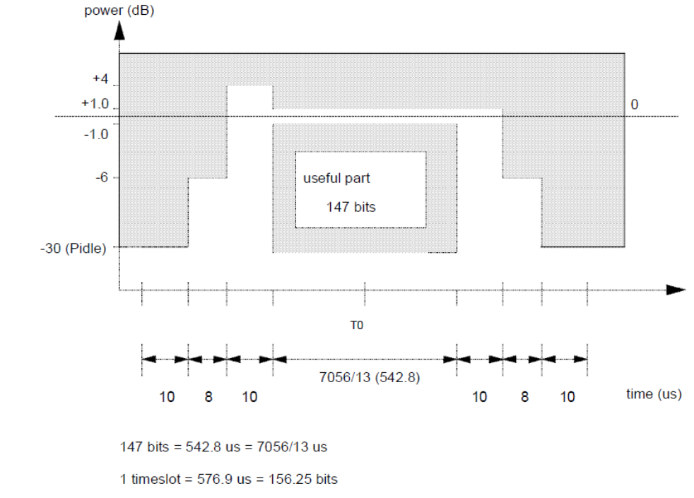

* The “TX OFF” Upper Limit is either -26 dBm or -55 dBc, whichever is higher.
Figure 16 Power vs Time mask for GSM800, GSM900, DCS1800
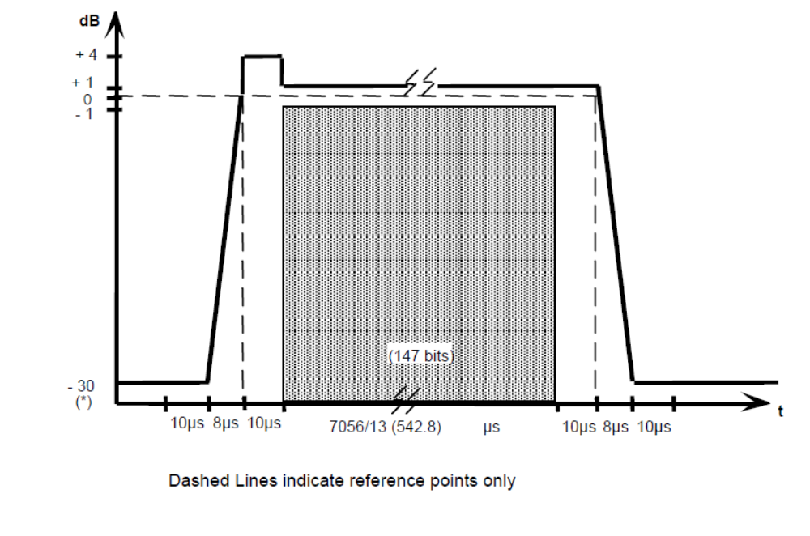

* The “TX OFF” Upper Limit is either -26 dBm or -55 dBc, whichever is higher.

Figure 17 Power vs Time mask for PCS 1900 GMSK modulation

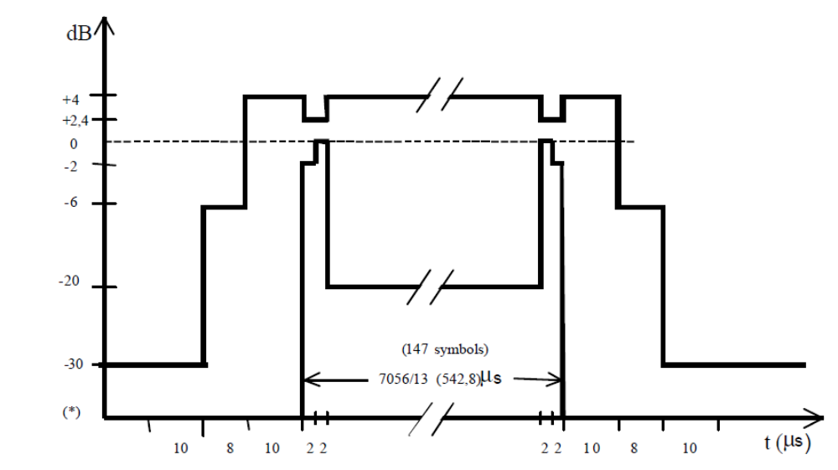
* The “TX OFF” Upper Limit is either -26 dBm or -55 dBc, whichever is higher.

Figure 18 Power vs Time mask for PCS 1900 8-PSK modulation

Test Condition
Test condition | Value | Remarks
Frequency | B, M, T | For each band test at Bottom, Middle and top frequencies.
Voltage |  | Nominal voltage
Temperature | +25 C, Extreme | Normal Room temperature, extreme temperature
Table 34. Test Condition

Test Procedure

- Connect test setup according to figure 15 with signal analyser to ANT1
- Calibrate the test setup (Cables, passives)
- Configure BTS in test mode
- Set the ARFCNs for all the TRXs to transmit on.
- For GMSK set all timeslots to TCH/FS encoding, modulation GMSK, 13th Frame blanking off, Training Sequence 0, and data stream PRBS.
- For EDGE set all timeslots to MCS5_P1 encoding, modulation 8PSK, 13th Frame blanking off, Training Sequence 0, and data stream PRBS.
- Set the timeslot to maximum power level on the TRX carrier to be tested.
- Select the relevant ARFCN, timeslot and expected power on the SA.
- Select the Power vs Time measurement on SA
- Record max and min results for a total of 200 bursts.
- Repeat until all required power levels, time slots, and ARFCNs have been tested.

Reference
3GPP TS 51 021 section 6.4

Test Case: spectrum due to modulation and wideband noise

Description
- Purpose
- To verify that the output RF spectrum due to modulation and wideband noise does not exceed the specified levels for an individual transceiver.
- Impact of failure
- The modulation, wideband noise spectra can produce significant interference in the relevant TX and adjacent bands.

Test Equipment List
- Power supply (E3634A or Equivalent)
- Signal Analyzer (N9010A or Equivalent)
- RF cables – 2 no’s
- 20dB Attenuator – 2 no’s

Test Setup
- Setup Block diagram

Signal
Analyzer (GSM)
CONNECT 1
Power Supply
Attenuator
ANT1 / ANT2
ANT1 / ANT2
High power termination

Figure 19 Test Set-up for Spectrum due to Modulation for offsets up to 1800kHz

Signal
Analyzer (GSM)
CONNECT 1
Power Supply
Tx Notch Filter
ANT1 / ANT2
ANT1 / ANT2
High power termination

Figure 20 Test Set-up for Spectrum due to Modulation for offsets 1800kHz from the carrier up to 6MHz outside the BTS transmit band

- Measurement Locations
- Antenna connectors
- Test Software settings
- Modify TIVA code for the corresponding band and flash it using CCS.
- Configuration

- The system under test shall be tested with one TRX active at three frequencies (first at RF channel B, second at RF channel M and third at RF channel T).
- The specification applies to the entire of the relevant transmit band and up to 2 MHz either side.
- During the test, only the TRX carrier under test shall be active (TX output cables from unused DTRX carriers can be disconnected if necessary). All the time slots for the TRX carrier shall be set to transmit at the same power level, modulated (GMSK or 8PSK) with a pseudo random bit sequence.
- The RF carrier power level shall be measured at the output of the BTS using the same method as in Section 6.1.2 (mean RF carrier power). The measured reference power level will be used to determine the correct specification limit in Table 37.

Frequency Offsets < 1800 KHz:
- The SA will take the measurement using the GMSK or EDGE Output RF Spectrum canned measurement. The SA shall have an external frame trigger from the BTS Frame Clock as well as the external reference from the BTS 10MHz clock. The measurement shall be taken using the time slot on feature to make sure the correct time slot is being sent from the TRX as well as being measured. The measurement type will be modulation, measurement method will be multi offset, measurement offset frequency list will be standard, direct time break frequency will be 400KHz, and the measurement shall be averaged over 200 sweeps.
- The BTS shall be set-up per Figure 20. The power measurement shall be repeated on carrier frequency using a resolution and video bandwidth of 30 KHz. It will use external frame trigger to measure over 50-90% of the useful part of the timeslot excluding midamble (343us to 491us), and the measured value over this part of the burst shall be averaged over at least 200 timeslots. The offsets listed in Table 35 shall be measured using the same method.
Offset (KHz) | Offset (KHz)
100 | 800
200 | 1000
250 | 1200
00 | 1400
600 | 1600
Table 35. Offsets measured for Adjacent Channel Power – Spectrum due to modulation and wideband noise < +/-1800 KHz.
Frequency Offsets ≥ 1800 KHz:
- The SA will take the carrier measurement using the Spectrum Analyzer mode. The SA shall have an external frame trigger from the BTS Frame Clock as well as the external reference from the BTS 10MHz clock. For the power measurements the trace type will be average and the detector type will be rms. The measurement shall be averaged over 200 sweeps from 20us to 557us.
- The BTS shall be setup per Figure 20. Note: be sure there is at least 10 dB of insertion loss between the BTS output and the input of the notch filter. This loss provides a good impedance match to the BTS and the filter. The power measurement shall be repeated using a resolution and video bandwidth of 100 KHz in frequency scan mode with a minimum sweep time of 75 ms and averaged over 200 sweeps. The swept frequency range will be ± 1800 KHz from the carrier to 2.2 MHz outside either end of the relevant. (i.e. the ranges [B – 2.2 MHz] ≤ range < [ARFCN – 1800 KHz] and [ARFCN + 1800 KHz] < range ≤ [T +_2.2 MHz])
Frequency offset (MHz) | Settings | Specifications
1.8 ≤ f < 6 | - Carrier Power RBW=30kHz, VBW=30kHz  - Offset RBW=100kHz, VBW=100kHz  - freq scan mode  - No trigger (free run),  - Trace Type: Average, Detector Type: Sample  - Sweep Time:75ms | See Table 37
f ≥ 6 | - Carrier Power RBW=30KHz, VBW=30KHz  - Offset RBW=100kHz, VBW=100kHz  - freq scan mode  - No trigger (free run),  - Trace Type: Average, Detector Type: Sample  - Sweep Time:75ms | See Table 37
Table 36. Modulation Spectrum and Wideband Noise Spectrum Analyzer Settings

Requirements
The requirements for this test are shown below:

Power level in dBm | Maximum relative level (dB) at specified carrier offsets (kHz),  using specified measurement (filter)bandwidths (kHz):
Power level in dBm | 100 | 200 | 250 | 400 | 600 to < 1200 | 1200 to < 1800 | 1800 to < 6000 | >= 6000
Power level in dBm | Measurement (filter)bandwidth;  30 kHz |  |  |  |  |  | Measurement (filter)  bandwidth; 100 kHz
< = 33 | +0.5 | -30 | -33 | -60 (note 1)  (see Exceptions below) | -60  (see Exceptions below) | -63  (see Exceptions below) | -65  (see Exceptions below) | -80  (see Exceptions below)
Table 37. Continuous modulation spectrum - maximum limits for BTS
Note 1: for 8-PSK, at normal symbol rate (NSR) the requirement is -56 dB
Note General: Normal symbol rate using linearised GMSK pulse-shaping filter and higher symbol rate using spectrally narrow pulse shaping filter
Exceptions:
- For a GSM900, GSM 850 BTS, if the limit according to table 37 is below -65 dBm, a value of -65 dBm shall be used instead
- For a DCS 1800, PCS 1900 BTS, if the limit according to table 37 is below -57 dBm, a value of -57 dBm shall be used instead.
- In the combined range 600 kHz to 6 MHz above and below the carrier frequency, in up to three bands of 200 kHz width centred on a frequency which is an integer multiple of 200 kHz, exceptions at up to -36 dBm are allowed.
- Above 6 MHz offset from the carrier frequency, in up to 12 bands of 200 kHz width centred on a frequency which is an integer multiple of 200 kHz, exceptions at up to -36 dBm are allowed.

Test Condition
Test condition | Value | Remarks
Frequency | B, M, T | For each band test at Bottom, Middle and top frequencies.
Voltage |  | Nominal voltage
Temperature | +25 C | Normal Room temperature,
Table 38. Test Condition

Test Procedure
Frequency Offsets < 1800 KHz
- Connect test setup according to figure 20 with signal analyser to ANT1
- Calibrate the test setup (Cables, passives)
- Set the ARFCNs for all the TRXs to transmit on.
- For GMSK set all timeslots to TCH/FS encoding, modulation GMSK, 13th Frame blanking off, Training Sequence 0, and data stream PRBS.
- For EDGE set all timeslots to MCS5_P1 encoding, modulation 8PSK, 13th Frame blanking off, Training Sequence 0, and data stream PRBS.
- Set the timeslot to maximum power level on the TRX carrier to be tested.
- Select the relevant ARFCN, timeslot and expected power on the SA.
- Select the SPECTRUM MOD key on the SA.
- Set the RBW and VBW and the measurement will use external frame trigger to measure over 50-90% of the useful part of the timeslot excluding midamble 343us to 491us, and the measured value over this part of the burst shall be averaged over at least 200.
- Note the values for the offsets from the carrier in Table 37.
- Repeat tests for the required static power levels: 0 through 7 for GMSK and 0 through 7 for 8PSK and ARFCN’s have been tested per 6.4.2.
- This measurement is performed at ambient conditions.

Frequency Offsets ≥ 1800 KHz:
- Connect test setup according to figure 20 with signal analyser to ANT1
- Calibrate the test setup (Cables, passives)
- Tune the notch filter to suppress the carrier to a minimum of –20dBm to allow the measurement to within the dynamic range of the spectrum Analyzer
- Set the ARFCNs for all the TRXs to transmit at full power on all timeslots.
- For GMSK set all timeslots to TCH/FS encoding, modulation GMSK, 13th Frame blanking off, Training Sequence 0, and data stream PRBS.
- For EDGE set all timeslots to MCS5_P1 encoding, modulation 8PSK, 13th Frame blanking off, Training Sequence 0, and data stream PRBS.
- Set the timeslot to maximum power level on the TRX carrier to be tested.
- Set the resolution and video bandwidths and set the spectrum analyzer to free run trigger mode. The power is measured across this band, and averaged over 200 sweeps.
- Record any peak and its frequency that is found during the sweeps.
- Repeat tests for the required static power levels: 0 and 7 for GMSK and 0 and 7 8PSK.
- This measurement is performed at ambient temperature only.

Reference
3GPP TS 51 021 section 6.5.1

Test Case: Switching transient spectrum

Description
- Purpose
- To verify that the output RF spectrum due to switching transients does not exceed the specified limits
- Impact of failure
- Noise spectra due to switching transients can produce significant interference in the relevant TX and adjacent bands.

Test Equipment List
- Power supply (E3634A or Equivalent)
- Signal Analyzer (N9010A or Equivalent)
- RF cables – 2 no’s
- 20dB Attenuator – 2 no’s

Test Setup
- Setup Block diagram

Signal
Analyzer (GSM)
CONNECT 1
Power Supply
Attenuator
ANT1 / ANT2
ANT1 / ANT2
High power termination

Figure 21 Test Set-up for Spectrum due to switching transients for offsets up to 1800kHz

- Measurement Locations
- Antenna connectors
- Test Software settings
- Modify TIVA code for the corresponding band and flash it using CCS.
- Configuration

- Setup the test per Figure 21. The reference power for relative measurements shall be measured by the same method mentioned in Section 6.1.2 (mean RF carrier power) for the TRX under test.
- The SA will take the measurement using the GMSK or EDGE Output RF Spectrum canned measurement. The SA shall have an external frame trigger from the BTS Frame Clock as well as the external reference from the BTS 10MHz clock.
- The measurement shall be taken using the time slot on feature to make sure the correct time slot is being sent from the TRX as well as being measured. The measurement type will be switching, measurement method will be multi offset, measurement offset frequency list will be standard, direct time break frequency will be 400KHz, and the measurement shall be averaged over 200 sweeps.
- The power shall be measured at the offsets 400, 600, 1200 and 1800 kHz from one of the carrier frequencies in the configuration with the test equipment parameters below
  - Reference Power Resolution bandwidth: 300
  - Resolution bandwidth: 30 kHz
  - Video bandwidth: 100 kHz
  - Zero frequency span
  - Peak hold enabled
  - 200 sweeps

- The test shall be performed on ARFCN’s B, M, and T with all timeslots active. TS1 will be measured.
- As this BTS supports RF power control then any active TRX shall be configured as illustrated in Figure 22

- As this BTS supports RF power control then any active TRX shall be configured as illustrated in Figure 23.

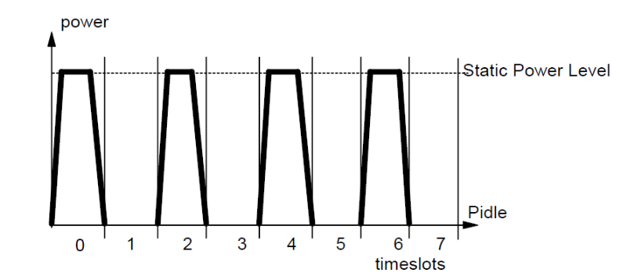
Figure 22 Power/Timeslot configuration for Switching Transients Spectrum
(RF Static Power Control)

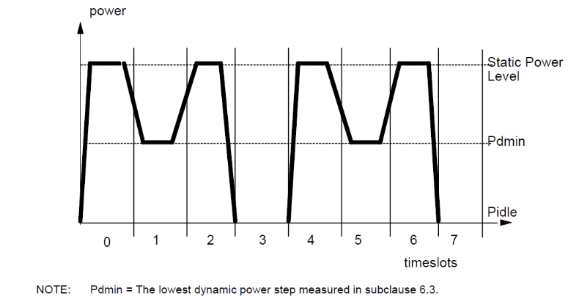

Figure 23 Power / timeslot configuration for Switching Transients Spectrum
(RF Power Control)
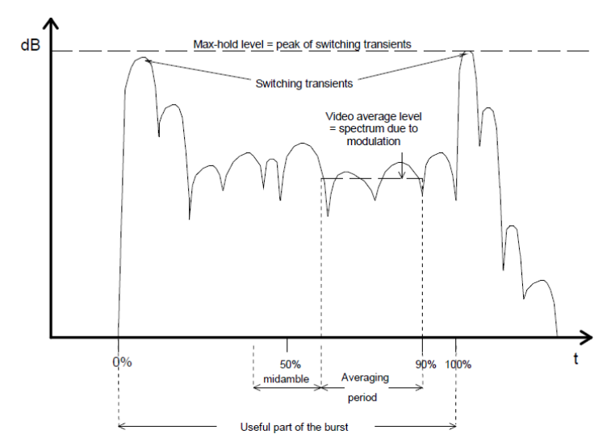

Figure 13 Example of a time waveform due to a burst as seen in a 30 kHz filter offset from the carrier

Requirements
The levels measured shall not exceed the limits shown in Table 39 or -36dBm whichever is the higher:
Offset (kHz): | Power (dBc):  GSM900,  GSM850  (GMSK) | Power (dBc):  GSM900,  GSM850  (8-PSK) | Power (dBc)  DCS1800  PCS 1900  (GMSK, 8-PSK
400 | -57 | -52 | -50
600 | -67 | -62 | -58
1200 | -74 | -74 | -66
1800 | -74 | -74 | -66
Note: dBc means relative to the output power at the BTS, measured at the same point and in a filter bandwidth of at least 300 kHz.
Table 39. Switching Transients Spectrum - Maximum Limits

Test Condition
Test condition | Value | Remarks
Frequency | B, M, T | For each band test at Bottom, Middle and top frequencies.
Voltage |  | Nominal voltage
Temperature | +25 C | Normal Room temperature,
Table 40. Test Condition

Test Procedure
Frequency Offsets < 1800 KHz
- Connect test setup according to figure 21 with signal analyser to ANT1
- Calibrate the test setup (Cables, passives)
- Synchronise the SA with the BTS by sending a BCCH signal on one TRX.
- Set the ARFCNs for all the TRXs to transmit on.
- For GMSK set all timeslots to TCH/FS encoding, modulation GMSK, 13th Frame blanking off, Training Sequence 0, and data stream PRBS.
- For EDGE set all timeslots to MCS5_P1 encoding, modulation 8PSK, 13th Frame blanking off, Training Sequence 0, and data stream PRBS.
- Set the timeslot to maximum power level on the TRX carrier to be tested.
- Set all timeslots to TCH, (Traffic Channels), and maximum power level on the DTRX carrier to be tested.
- Select the relevant ARFCN, timeslot and expected power on the SA.
- Select the SWITCH SPECTRUM key on the SA.
- Record the values for the offsets from the carrier noted in Table 39.
- This measurement is performed and repeated for conditions mentioned in 6.1.5.3 (iv).

Reference
3GPP TS 51 021 section 6.5.2

Test Case: Spurious emission - Inside the BTS Transmit Band

Description
- Purpose
- This test measures spurious emissions from the BSS transmitter antenna connector inside the BSS relevant transmit band, while one transmitter is in operation.
- Impact of failure
- A GSM transmitter must not put energy into the wrong parts of the spectrum. The failure of this test will result in interference to other users of the GSM system in the same band. This will also result in non-compliance.

Test Equipment List
- Power supply (E3634A or Equivalent)
- Signal Analyzer (N9010A or Equivalent)
- RF cables – 2 no’s
- 20dB Attenuator – 2 no’s

Test Setup
- Setup Block diagram
Signal
Analyzer (GSM)
CONNECT 1
Power Supply
Tx Notch Filter
ANT1 / ANT2
ANT1 / ANT2
High power termination

Figure 25 Manual Test Set-up for Transmitter Conducted Spurious Emissions from the Antenna Connector: Inside the BTS Transmit Band
- Measurement Locations
- Antenna connectors

- Test Software settings
- Modify TIVA code for the corresponding band and flash it using CCS.
- Configuration
- The TX shall be tested on RF channels B, M and T.
- Only 1 TRX carrier will be transmitting, all other TRXs shall be inactive (they may be disconnected if necessary, be sure to terminate disconnected ports properly).
- This test is only performed at ambient temperature.
- The SA will take the measurement using the Spectrum Analyzer mode. The SA shall have the external reference from the BTS 10MHz clock.
- For the power measurements the trace type will be average and the detector type will be rms.
- For the spurious measurements the SA will be configured as below.
  - The measurement shall be averaged over 200 sweeps and the frequency range will be ± 1800 KHz from the carrier to 2.2 MHz outside either end of the relevant. (I.e. the ranges [B – 2.2 MHz] ≤ range < [ARFCN – 1800 KHz] and [ARFCN + 1800 KHz] < range ≤ [T +_2.2 MHz]).
  - See the following Table 41 for reference.
- Set the timeslot to maximum power level on the TRX carrier to be tested.

Frequency offset (MHz) | Settings | Specifications
1.8 ≤ f < 6 | RBW=30kHz, VBW=100kHz, freq scan mode, no trigger (free run), Trace Type: Peak Hold, Detector Type: Sample, Sweep Time is auto. | -36dBm
f ≥ 6 | RBW=100kHz, VBW=300kHz, freq scan, no trigger (free run), Trace Type: Peak Hold, Detector Type: Sample, Sweep Time is auto. | -36dBm
Table 41. In-band Spurious Emission Spectrum Analyzer Settings

Requirements
The maximum power measured shall not exceed -36.0 dBm.

Test Condition
Test condition | Value | Remarks
Frequency | B, M, T | For each band test at Bottom, Middle and top frequencies.
Voltage |  | Nominal voltage
Temperature | +25 C | Normal Room temperature,
Table 42. Test Condition

Test Procedure
Frequency Offsets < 1800 KHz
- Connect test setup according to figure 25 with signal analyser to ANT1
- Calibrate the test setup (Cables, passives)
- Set the ARFCNs for the TRX to transmit on.
- For GMSK set all timeslots to TCH/FS encoding, modulation GMSK, 13th Frame blanking off, Training Sequence 0, and data stream PRBS.
- For EDGE set all timeslots to MCS5_P1 encoding, modulation 8PSK, 13th Frame blanking off, Training Sequence 0, and data stream PRBS.
- Set the timeslot to maximum power level on the DTRX carrier to be tested.
- Set the spectrum Analyzer detector and trace type.
- Set the RBW, VBW, trigger type, and sweep count for offsets.
- Record any peak and its frequency that is found during the sweeps

Reference
3GPP TS 51 021 section 6.6.1

Test Case: Spurious emission - Outside the BTS Transmit Band

Description
- Purpose
- The purpose of this test is to measure harmonics and spurious emissions from the BTS transmitter antenna connector outside the BTS transmit band, while all of the transmitters are in operation. It also tests the intra-BTS Intermodulation requirements outside the BTS transmit band
- Impact of failure
- A GSM transmitter must not put energy into the wrong parts of the spectrum. The failure of this test will result in interference to other users outside the GSM band and other systems. This will also result in non-compliance.

Test Equipment List
- Power supply (E3634A or Equivalent)
- Signal Analyzer (N9010A or Equivalent)
- RF cables – 2 no’s
- 20dB Attenuator – 2 no’s

Test Setup
- Setup Block diagram
Signal
Analyzer (GSM)
CONNECT 1
Power Supply
Attenuator
ANT1 / ANT2
ANT1 / ANT2
High power termination

Figure 26 Manual Test Set-up for Transmitter Conducted Spurious Emissions from the Antenna Connector: Outside the BTS Transmit Band

- Measurement Locations
- Antenna connectors
- Test Software settings
- Modify TIVA code for the corresponding band and flash it using CCS.
- Configuration
- The TX shall be tested according to Table 22 and Table 23.
- All TRXs shall be set to transmit at full power on all timeslots.
- Based on Table 22 and Table 23, frequency range under test is swept with Max Hold.
- When a frequency range under test is swept with Averaging, all the TRXs combined shall be tested on BMT.
- The SA will take the measurement using the Spectrum Analyzer mode. The SA shall have an external reference from the BTS 10MHz clock.
- For the measurements the trace type will be average and the detector type will be sample or the trace type will be Max and the detector type will be sample. The measurement shall be averaged over 200 sweeps with the sweep time set to auto.
- This test is only performed at ambient temperature.
Type Approval Special Test case
- The TX shall be tested according to Table 24 and Table 25. All TRXs shall be set to transmit at full power on alternating timeslots. Based on Table 24 and Table 25, all frequency ranges tested will be with Max Hold,

Requirements
The following tables list the maximum levels of Spurious Emissions allowed from the Transmitter Antenna Connector, for each system.
Note1: In practice the spurious emissions on BTS own receiver band shall be much lower (~30dB antenna isolation) than required in above mentioned specifications in order to meet sensitivity requirements for receiver due the duplexed antenna lines.
Note2: In following tables RX band requirements are based on duplexed antenna sensitivity, 3GPP 51.021 and 45.005 requirement is -98 dBm.
The co-siting and other country specific requirements have been taken into account as following:
- For GSM800: Co-Siting with GSM1900, GSM1800 and 3G worldwide band (2500 –2690 MHz).
- For GSM900: Co-Siting with GSM400, GSM1800, WCDMA FDD, TDD1 and TDD2. In addition, tighter BAPT limits and 3G worldwide band (2500 –2690 MHz).
- For GSM1800: Co-Siting with GSM400, GSM800, GSM900, WCDMA FDD, TDD1 and TDD2. In addition, tighter BAPT limits and 3G worldwide band (2500 –2690 MHz)
- For GSM1900: Co-Siting with GSM800. In addition, FCC range from 12.75GHz-19.9GHz and 3G worldwide band (2500 –2690 MHz).

Testing of 900
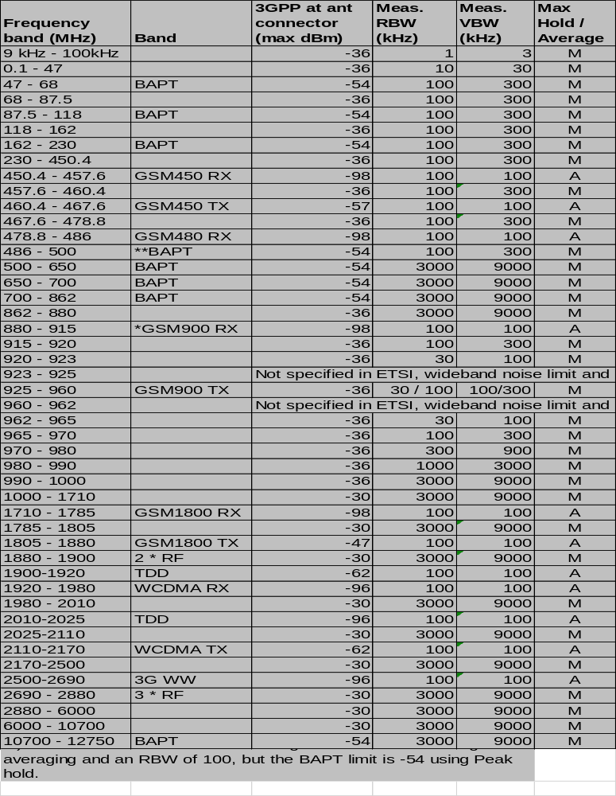
* Note - For RX band Spurs, limit is based on TRX requirement to guarantee all channel sensitivity, since all channel sensitivity is measured at BTS level, -115 dBm can be used.
Table 43. Limits for Spurious Emissions from the Transmitter Antenna Connector (900)

Testing of 1800
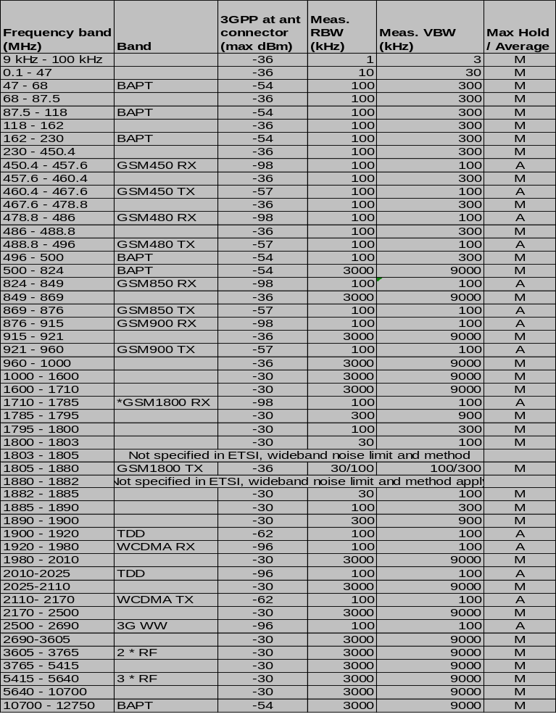

* Note - For RX band Spurs, limit is based on TRX requirement to guarantee all channel sensitivity, since all channel sensitivity is measured at BTS level, -115 dBm can be used
Table 44. Limits for Spurious Emissions from the Transmitter Antenna Connector (1800)

Testing of 900 for Type Approval
Case # | Start Frequency | Stop Frequency | Trace Type | 3GPP Limit | TA Limit | Meas RBW (MHz) | Meas VBW (MHz)
0 | 0.1 | 50 | Max | -36 |  | 0.01 | 0.03
1 | 50 | 450.4 | Max | -36 | -54 | 0.1 | 0.3
2 | 450.4 | 457.6 | Avg | -36 | -98 | 0.1 | 0.1
3 | 450.4 | 460.4 | Max | -36 |  | 0.1 | 0.3
4 | 460.4 | 467.6 | Avg | -36 | -57 | 0.1 | 0.1
5 | 460.4 | 478.8 | Max | -36 |  | 0.1 | 0.3
6 | 478.8 | 486 | Avg | -36 | -98 | 0.1 | 0.1
7 | 478.8 | 488.8 | Max | -36 |  | 0.1 | 0.3
8 | 488.8 | 496 | Avg | -36 | -57 | 0.1 | 0.1
9 | 488.8 | 500 | Max | -36 | -54 | 0.1 | 0.3
10 | 500 | 650 | Max | -36 | -54 | 3 | 9
11 | 650 | 700 | Max | -36 | -54 | 3 | 9
12 | 700 | 820 | Max | -36 | -54 | 3 | 9
13 | 820 | 862 | Max | -36 | -54 | 3 | 9
14 | 862 | 895 | Max | -36 |  | 3 | 9
15 | 880 | 915 | Avg | -36 | -115 | 0.1 | 0.1
16 | 895 | 905 | Max | -36 |  | 1 | 3
17 | 905 | 915 | Max | -36 |  | 0.3 | 1
18 | 915 | 920 | Max | -36 |  | 0.1 | 0.3
19 | 920 | 923 | Max | -36 |  | 0.03 | 0.1
20 | 962 | 965 | Max | -36 |  | 0.03 | 0.1
21 | 965 | 970 | Max | -36 |  | 0.1 | 0.3
22 | 970 | 980 | Max | -36 |  | 0.3 | 1
23 | 980 | 990 | Max | -36 |  | 1 | 3
24 | 990 | 1000 | Max | -36 |  | 3 | 9
25 | 1000 | 1500 | Max | -30 |  | 3 | 9
26 | 1500 | 1710 | Max | -30 |  | 3 | 9
27 | 1710 | 1785 | Avg | -30 | -98 | 0.1 | 0.1
28 | 1710 | 1805 | Max | -30 |  | 3 | 9
29 | 1805 | 1880 | Avg | -30 | -47 | 0.1 | 0.1
30 | 1805 | 1880 | Max | -30 |  | 3 | 9
31 | 1880 | 1900 | Max | -30 |  | 3 | 9
32 | 1900 | 1920 | Avg | -30 | -62 | 0.1 | 0.1
33 | 1900 | 1910 | Max | -30 |  | 3 | 9
34 | 1920 | 1980 | Avg | -30 | -96 | 0.1 | 0.1
35 | 1910 | 2010 | Max | -30 |  | 3 | 9
36 | 2010 | 2025 | Avg | -30 | -96 | 0.1 | 0.1
37 | 2010 | 2110 | Max | -30 |  | 3 | 9
38 | 2110 | 2170 | Avg | -30 | -62 | 0.1 | 0.1
39 | 2110 | 2500 | Max | -30 |  | 3 | 9
40 | 2500 | 2690 | Avg | -30 | -96 | 0.1 | 0.1
41 | 2500 | 3000 | Max | -30 |  | 3 | 9
42 | 3000 | 10700 | Max | -30 |  | 3 | 9
43 | 10700 | 12750 | Max | -30 | -54 | 3 | 9

Table 45. Limits for Spurious Emissions from the Transmitter Antenna Connector (900 Type Approval with Alternating Timeslots)

Testing of 1800 for Type Approval
Case # | Start Frequency | Stop Frequency | Trace Type | 3GPP Limit | TA Limit | Meas RBW (MHz) | Meas VBW (MHz)
0 | 0.1 | 50 | Max | -36 |  | 0.01 | 0.03
1 | 50 | 450.4 | Max | -36 | -54 | 0.1 | 0.3
2 | 450.4 | 457.6 | Avg | -36 | -98 | 0.1 | 0.1
3 | 450.4 | 460.4 | Max | -36 |  | 0.1 | 0.3
4 | 460.4 | 467.6 | Avg | -36 | -57 | 0.1 | 0.1
5 | 460.4 | 478.8 | Max | -36 |  | 0.1 | 0.3
6 | 478.8 | 486 | Avg | -36 | -98 | 0.1 | 0.1
7 | 478.8 | 488.8 | Max | -36 |  | 0.1 | 0.3
8 | 488.8 | 496 | Avg | -36 | -57 | 0.1 | 0.1
9 | 488.8 | 500 | Max | -36 | -54 | 0.1 | 0.3
10 | 500 | 824 | Max | -36 | -54 | 3 | 9
11 | 824 | 876 | Max | -36 |  | 3 | 9
12 | 876 | 915 | Avg | -36 | -98 | 0.1 | 0.1
13 | 921 | 960 | Avg | -36 | -57 | 0.1 | 0.1
14 | 876 | 960 | Max | -36 | -54 | 3 | 9
15 | 960 | 1000 | Max | -36 |  | 3 | 9
16 | 1000 | 1600 | Max | -30 |  | 3 | 9
17 | 1600 | 1710 | Max | -30 |  | 3 | 9
18 | 1710 | 1785 | Avg | -30 | -115 | 0.1 | 0.1
19 | 1710 | 1775 | Max | -30 |  | 3 | 9
20 | 1775 | 1785 | Max | -30 |  | 1 | 3
21 | 1785 | 1795 | Max | -30 |  | 0.3 | 1
22 | 1795 | 1800 | Max | -30 |  | 0.1 | 0.3
23 | 1800 | 1803 | Max | -30 |  | 0.03 | 0.1
24 | 1882 | 1885 | Max | -30 |  | 0.03 | 0.1
25 | 1885 | 1890 | Max | -30 |  | 0.1 | 0.3
26 | 1890 | 1900 | Max | -30 |  | 0.3 | 1
27 | 1900 | 1920 | Avg | -30 | -62 | 0.1 | 0.1
28 | 1900 | 1910 | Max | -30 |  | 1 | 3
29 | 1920 | 1980 | Avg | -30 | -96 | 0.1 | 0.1
30 | 1910 | 2010 | Max | -30 |  | 3 | 9
31 | 2010 | 2025 | Avg | -30 | -96 | 0.1 | 0.1
32 | 2010 | 2110 | Max | -30 |  | 3 | 9
33 | 2110 | 2170 | Avg | -30 | -62 | 0.1 | 0.1
34 | 2110 | 2500 | Max | -30 |  | 3 | 9
35 | 2500 | 2690 | Avg | -30 | -96 | 0.1 | 0.1
36 | 2500 | 3000 | Max | -30 |  | 3 | 9
37 | 3000 | 10700 | Max | -30 |  | 3 | 9
38 | 10700 | 12750 | Max | -30 | -54 | 3 | 9

Table 46. Limits for Spurious Emissions from the Transmitter Antenna Connector (1800 Type Approval with Alternating Timeslots)

Test Condition
Test condition | Value | Remarks
Frequency | B, M, T | For each band test at Bottom, Middle and top frequencies.
Voltage |  | Nominal voltage
Temperature | +25 C | Normal Room temperature,
Table 47. Test Condition

Test Procedure
- Connect test setup according to figure 26 with signal analyser to ANT1
- Calibrate the test setup (Cables, passives)
- Set the ARFCNs for all the TRXs to transmit at full power on all timeslots.
- For GMSK set all timeslots to TCH/FS encoding, modulation GMSK, 13th Frame blanking off, Training Sequence 0, and data stream PRBS.
- For EDGE set all timeslots to MCS5_P1 encoding, modulation 8PSK, 13th Frame blanking off, Training Sequence 0, and data stream PRBS.
- Set the timeslot to maximum power level on the TRX carrier to be tested.
- Set the spectrum Analyzer to max/peak hold or averaging according to, Table 22, Table 23, Table 24 and Table 25.
- Set the RBW and VBW according to Table 22, Table 23, Table 24 and Table 25.
- Set sweep time to Auto.
- Record up to six peaks and their frequencies that are found during the sweeps. Also record the minimum level and its frequency that is found during the sweep for noise floor information.

Frequency Band | Frequency Offset | RBW
100kHz* – 50MHz |  | 10kHz
50MHz – 500MHz |  | 100kHz
500MHz – 12.75GHz** and outside the relevant transmit band. | (Offset from the edge of the relevant transmit band)
 |  2MHz | 30kHz
 |  5MHz | 100kHz
 |  10MHz | 300kHz
 |  20MHz | 1MHz
 |  30MHz | 3MHz
* To show 3GPP TS 45.005 [5] compliance, measure from 9 KHz.
** For 1900 only, measure to 19.9 GHz (10th harmonics of fundamental)
Table 48. 3GPP TS 51.021 Resolution Bandwidths used in Transmitter Conducted Spurious Emissions from the Antenna Connector - Outside the BTS Transmit Band.

Reference
3GPP TS 51 021 section 6.6.2

Test Case: Intermodulation attenuation (GSM900, DCS1800)

Description
- Purpose
- To verify that the level of intermodulation products produced inside the RX and TX bands (due to the leakage of RF power between transmitters that are operating in close vicinity of each) do not exceed the specified limit
- The intermodulation attenuation is the ratio of the power level of the wanted signal to the power level of an intermodulation component. It is a measure of the capability of the transmitter to inhibit the generation of signals in its non-linear elements caused by the presence of the carrier and an interfering signal reaching the transmitter via the antenna, or by nonlinear combining and amplification of multiple carriers.
- Impact of failure
  - Failure of this test case will lead to unwanted emission and non-compliance to 3GPP requirements.

Test Equipment List
- Power supply (E3634A or Equivalent)
- Signal Analyzer (N9010A or Equivalent)
- Signal generator (N5182B or Equivalent)
- Directional coupler, Isolator, GSM notch filter, Wideband gain amplifier

Test Setup
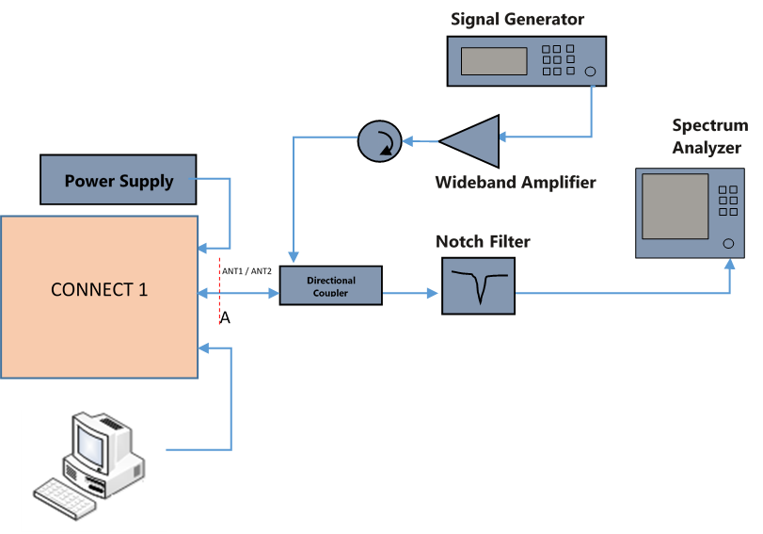
- Setup Block diagram

Figure 27 Manual Test Set-up for Transmitter Intermodulation attenuation
- Measurement Locations
- Antenna connectors
- Test Software settings
- Modify TIVA code for the corresponding band and flash it using CCS.
- Configuration
- The TX shall be tested on RF channel M.
- Only 1 TRX carrier will be transmitting, all other TRXs shall be inactive (they may be disconnected if necessary, be sure to terminate disconnected ports properly).
- This test is only performed at ambient temperature.
- The test signal (interferer) shall be unmodulated and the frequency shall be X MHz offset from the frequency of the RF transmit equipment under test. For X, refer to table below.
- The TRX under test shall be set to highest static power control level and the test signal power level shall be adjusted 30 dB below this value.
- The power level of the test signal shall be measured at the antenna output end of the coaxial cable, when disconnected from the RF transmit equipment and then correctly matched into 50 ohms. The antenna output power of the RF transmit equipment shall be measured directly at the antenna output terminal connected to an artificial antenna.
- The power of all third and fifth order intermodulation products shall be measured

Requirements
 | Normal BTS
Transmit band Carrier Offset (kHz) | 100 | 200 | 250 | 400 | 600 to < 1200 | 1200 to < 1800 | 1800 to < 6000 | > 6000
Limit (dBc)  (Note 1) | +0.5 | -30 | -33 | -60 | -60 to -70 | -63 to -73 | -65 to -75 | -70dBc  or -36 dBm
Allowable failures | 0 |  |  |  | 3 |  |  | 1 in 100
Limit of failure (dBm) | -- |  |  |  | -36 |  |  | -60 dBc  or  -26 dBm
Note 1:
For a GSM900 BTS, if the limit is below -65dBm, a value of -65dBm shall be used instead.
For a DCS1800 BTS, if the limit is below -57dBm, a value of -57dBm shall be used instead.
Table 49. Intermodulation attenuation specification

Test Condition
Test condition | Value | Remarks
Frequency | M
Voltage |  | Nominal voltage
Temperature | +25 C | Normal Room temperature,
Table 50. Test Condition

Test Procedure
- Connect test setup according to figure 27
- Tune notch filter to corresponding ARFCN frequency being transmitted.
- Calibrate the test setup (Cables, passives)
- Set the ARFCNs for the TRX to transmit on.
- Set the Tx power to maximum static power level (33dBm)
- Set interferer frequency according to requirements table, set the Interfere power level 30dB below Tx power (+3dBm)
- Set the spectrum Analyzer to measure IMD3 products. Set the RBW, VBW, trigger type, and sweep count.

Reference
3GPP TS 05.05 [2] sub clause 4.7.1
3GPP TS 51.021 [3] sub clause 6.7
Test case reference: Sys Tx 1.7

Test Case: Intra BTS Intermodulation attenuation

System RF Rx

Connect 1 GSM BTS has two Receive chains, each can be configured for any one of the four bands – GSM850, GSM900, GSM1800 and GSM1900. The reference plane is BTS Antenna connector.

Test Purpose and Description
The purpose of this test is to verify and validate Base Station receiver performance. The tests include receiver sensitivity measurement under static and under fading scenarios. The receivers are tested for impact of interferer signals.
Verification and validation of the BTS receiver covers following functions and features:
- NER static
- NER EQ-50
- High level RACH (NER RACH), static
- Static reference sensitivity level, TCH/FS, 8PSK
- Static sensitivity reference level, all other logical channels
- Multipath sensitivity level, TCH/FS, 8PSK
- Multipath sensitivity level, all other logical channels
- Reference interference level, TCH/FS, 8PSK
- Reference interference level, all other logical channels
- Blocking and spurious response rejection
- Intermodulation rejection, TCH/FS, 8PSK
- AM suppression, TCH/FS, 8PSK
- Received signal measurement accuracy
- Received signal level & selectivity
- Spurious emissions from the RX antenna connector

Test Case: NER static

Test Case: NER EQ-50

Test Case: High level RACH (NER RACH), static

Test Case: Static reference sensitivity level, TCH/FS, 8PSK

Test Case: Static sensitivity reference level, all other logical channels

Test Case: Multipath sensitivity level , TCH/FS, 8PSK

Test Case: Multipath sensitivity level, all other logical channels

Test Case: Reference interference level, TCH/FS, 8PSK

Test Case: Reference interference level, all other logical channels

Test Case: Blocking and spurious response rejection

Test Case: Intermodulation rejection, TCH/FS , 8PSK

Test Case: AM suppression, TCH/FS, 8PSK

Test Case: Received signal measurement accuracy

Test Case: Received signal level & selectivity

Test Case: Spurious emissions from the RX antenna connector

System RF GPS
Connect 1 GSM BTS has sync module that has a GPS receiver. The GPS receiver provides a GPSDO reference at 40MHz to clean up the system clock.

Test Purpose and Description
The purpose of these tests is to validate the performance of GPS receiver in standalone mode and in coexistence condition with GSM transmission. Following are the test cases covered in this sections
- GPS lock
- GPS-GSM coexistence

Test Case: GPS lock

Description
- Purpose
- To validate the performance of GPS receiver under open sky condition.
- To verify GPSDO lock condition.
- Impact of failure
- GPSDO is crucial for system clock and RF performance. A failure to achieve GPSDO lock will result in higher phase error in clock outputs and degraded modulation accuracy.

Test Equipment List
- Lead acid battery
- Debug connector

Test Setup
- Setup Block diagram
Lead-Acid battery
CONNECT 1
GPS ANTENNA PORT

Figure 28 GPS lock test setup block diagram

- Measurement Locations
- GPS Antenna.
- Test Software settings
- TIVA build with GPS lock detect logging enabled.

- Configuration
- Enable GPS lock detect logging.

Requirements
Parameter | Value
GPS lock detect | OK
Time for GPS lock detect | < 15 minutes

Table 51. GPS lock requirement specification

Test Condition
Test condition | Value | Remarks
Voltage |  | Nominal voltage
Temperature | +25 C, | Normal Room temperature,
Table 52. Test Condition

Test Procedure

- Connect test setup according to figure 28
- Enable GPS lock detect logging.
- Place the BTS such that the GPS antenna has clear view of open sky (GPS satellites)
- Power on the BTS, monitor GPS lock detect logs
- When GPS lock is achieved, evaluate the time taken for lock.
- Power off the BTS, repeat steps 4 and 5.

Reference
Test case reference: Sys GPS 1.1

Test Case: GPS – GSM coexistence

Description
- Purpose
- To validate the performance of GPS coexistence with GSM. To verify receiver performance when operated along with GSM transmission.
- Impact of failure
- GPSDO is locked to GPS clock. Failure of GPS receiver to achieve GPS fix will result in failure to get GPSDO lock. This in turn will results in in higher phase error in clock outputs, thereby resulting in degraded modulation accuracy.

Test Equipment List
- GPS simulator
- Signal analyzer
- Power supply
- Directional couplers, isolators, variable attenuator.
- Debug connector

Test Setup
- Setup Block diagram
- RFSDR board along with LINUX PC with OSMO stack
- GBC board with debug board attached. This is required to capture GPS lock detect message
- SYNC module attached to GBC board.
- USB to UART adaptor board, connected to the SYNC module to capture NMEA messages.
RF-SDR
ANT1 / ANT2
Directional Coupler
A
Power Meter
Power Supply
GBC
SYNC
Power Supply
DEBUG
USB (OSMO)
USB (TIVA)
USB
(TXD-GPS, USB-UART)
USB to UART
Adaptor
Directional Coupler

VARIABLE
ATTENUATOR
-10dB
Coupler
TERMINATION
GSM
GPS
GPS Signal Generator

Figure 29 GPS-GSM coexistence test setup block diagram

- Measurement Locations
- GPS Antenna
- Test Software settings
- TIVA build with GPS lock detect logging enabled.
- Configuration
- Enable GPS lock detect logging.

Requirements
Parameter | Value
With and input of -130dBm, GPS Fix and Lock to be achieved for up to a minimum of GPS-GSM isolation of | 35 dB
Time for GPSDO lock detect for GPS input of -130dBm and GPS-GSM coupling of 35dB | < 15 minutes

Table 53. GPS-GSM isolation requirement specification

Test Condition
Test condition | Value | Remarks
Voltage |  | Nominal voltage
Temperature | +25 C, | Normal Room temperature,
Table 54. Test Condition

Test Procedure
- Plugin SYNC module,
  - initialize GPS lock logging and NMEA logging
  - Check C/No numbers
  - Check the time taken for GPS lock
- Initialize GSM carrier for GSM900
  - Set GSM transmit carrier power to -130dBm
  - Check C/No numbers (typical good value is between 33 to 50)
  - Increase the GSM GPS signal coupling by reducing the attenuation (Variable attenuator)
- Record the C/N for each variable attenuation state till the C/N degrades to the level where GPS fix is lost.
- Record the GPSDO lock time for GSM-GPS isolation of 35dB

Reference
Test case reference: Sys Rx 1.15

System Electrical Compliance

The system need to comply with relevant compliance specifications and guidelines according to FCC, 3GPP, ETSI, and other relevant standards

Test Purpose and Description
The purpose of this test is to validate the compliance of system according to the standards applicable for the BTS and indicated in requirement specification. These tests will be performed at external labs equipped to carry out the validation tests. These labs are also authorized to issue compliance certification.

Test Case: Radiated emission

Test Case: Conducted emission

Test Case: Radiated electromagnet field immunity

Test Case: Fast transients immunity

Test Case: Ethernet fast transient immunity

Test Case: RF common mode immunity

Test Case: Ethernet RF common mode immunity

Test Case: Safety requirements

Test Case: ESD

Test Case: DC port lightning surge protection (OVP)

Test Case: Antenna port lightning surge

Test Case: Ethernet lightning surge

Test equipment
Equipment | Manufacturer | Model
Vector Network Analyzer | Keysight | E5071C
Vector Signal Analyzer | Keysight | N9010A, N9020A
Signal Generator | Keysight | N5182B
DC Power Supply | Keysight | E3632A, E3634A, E3631A
Solar Array Simulator | Agilent | E4350B
Digital Multimeter | Keysight | 34401A
Oscilloscope | Keysight | MSO9404A, 4GHz Mixed Signal Osc
General purpose Amplifier | Minicircuits | ZVA-183-S+
Lead Acid Battery | Amaron | 65Ah – Amaron Quanta 12AL065
Li-Ion Battery | -- | 3000mAH - LP103090TB
LTPoE++ PSE injector | Eten Technologies | PS-201G++
Electronic load | KPAS Instronics | KM-0611

Test software licenses

Equipment | Manufacturer | Model
Signal Studio for GSM/EDGE/Evo | Keysight | N7605, N7602
GSM / EDGE Measurement application | Keysight | N9071A
Signal Generator | Keysight | N5182B
Signal Studio – GPS | Keysight | N7609B

References

- HW_Requirement_Specification_Facebook-Connect-1
- DVT_checklist_RF_SDR_GBC_System
- 3GPP TS 51 021
- 3GPP TS 45.005

